Map projection properties:
considerations for small-scale GIS Applications

by
Eric M. Delmelle

A project submitted to the Faculty of the Graduate School of
State University of New York at Buffalo in partial fulfillments of
the requirements for the degree of

Master of Arts
Geographical Information Systems and Computer Cartography
Department of Geography
September 2001

Master Advisory Committee:
David M. Mark
Douglas M. Flewelling

Abstract
Since Ptolemeus established that the Earth was round, the number of map projections has increased considerably. Cartographers have at present an impressive number of projections, but often lack a suitable classification and selection scheme for them, which significantly slows down the mapping process. Although a projection portrays a part of the Earth on a flat surface, projections generate distortion from the original shape. On world maps, continental areas may severely be distorted, increasingly away from the center of the projection.
Over the years, map projections have been devised to preserve selected geometric properties (e.g. conformality, equivalence, and equidistance) and general properties (e.g. shape of the parallels and meridians, the representation of the Pole as a line or a point and the ratio of the axes). Unfortunately, Tissot proved that the perfect projection does not exist since it is not possible to combine all geometric properties together in a single projection. In the twentieth century however, cartographers have not given up their creativity, which has resulted in the appearance of new projections better matching specific needs. This paper will review how some of the most popular world projections may be suited for particular purposes and not for others, in order to enhance the message the map aims to communicate. Increasing developments in Geographical Information Systems (GIS) along with their user-friendliness have resulted in a substantial multiplication of GIS applications. The use of these systems by non-experienced users might lead to an unconsidered choice of projection framework and subsequently the message the map attempts to communicate can significantly be devaluated. Moreover the majority of desktop GIS does not offer a large variety of alternatives and are not flexible to projection customization. The selection of the final projection framework can be optimized through a process that makes the user aware of the properties of every supported projection.

KEYWORDS: map projection distortion, Geographical Information Systems (GIS), data transfer, map projection selection

LIST OF contents
1 Introduction 1
1.1 Introduction to map projections 3
1.2 Different classes of projections 5
1.3 Distortion 11
1.4 Special and geometric properties 18
2 Purpose statement 24
2.1 Objectives 25
2.2 Literature review 28
2.3 Methods and limitations 30
3 Selected map projections 24
3.1 Cylindrical projections 31
3.2 Pseudocylindrical projections 53
3.3 Polyconic and pseudoconic projections 68
3.4 Minimum-error projections 82
4 Map projection issues for GIS applications 93
4.1 Data transfer in GIS among supported projections 94
4.2 Map projection selection schemes for GIS applications 96
4.3 Considerations for an objective approach 108
4.4 Towards a more interactive solution? 109
4.5 Conclusion 111
5 Conclusion, outlook and future research 112
6 Bibliography 114

LIST OF FIGURES

Fig 1.1. The map projection process 4
Fig 1.2. The Earth can be projected onto three main surfaces 6
Fig 1.3. and 1.4. the transverse and oblique aspect on Mercator 7
Fig 1.5.and 1.6. The choice of the central meridian 8
Fig 1.7. Maling 's classification scheme 9
Fig 1.8. and 1.9. Tissot's indicatrices 16
Fig 3.1. The world on the Plate Carrée projection 33
Fig 3.2. The Equirectangular cylindrical projection 35
Fig 3.3. The Gall stereographic projection 36
Fig 3.4. The Miller cylindrical projection 39
Fig 3.5. The Gall-Peters' projection centered on Greenwich 41
Fig 3.6. The Behrman equal area projection 44
Fig 3.7. The world on the Lambert equal area projection 45
Fig 3.8. The Mercator conformal projection limited ± 85° 48
Fig.3.9. Mercator projection centered 60°N, 35°W. 30° graticule 50
Fig 3.10. and 3.11. the gnomonic and orthographic projection showing Great circles from Oslo to Anchorage and San Diego 50
Fig. 3.12. Eckert IV equal-area projection 55
Fig. 3.13. Eckert VI equal-area projection 56
Fig 3.14. The Mc Bryde-Thomas equal-area projection 58
Fig 3.15. The sinusoidal equal-area projection 60
Fig 3.15. The Mollweide equal-area projection 61
Fig 3.16. The Robinson projection 64
Fig 3.17. The Kravaiskiy VI/Wagner I projection 66
Fig 3.18. The world on the heart-shaped Bonne equal area projection 69
Fig 3.19. The Hammer-Aitoff equal-area projection 71
Fig 3.20. The Aitoff-Wagner projection 73
Fig 3.21. The Hammer-Wagner equal-area projection 75
Fig 3.22. The Winkel-Tripel projection 76
Fig 3.23. The Lambert conformal projection in a circle 78
Fig 3.24 The Van der Grinten projection 80
Fig 3.25. The Aribert Peters projection 86
Fig 3.26. The Canters projection 88
Fig 3.27. The tri-optimal projection 90
Fig 4.1. A proposed procedure for the selection of map projections 107
Fig 4.2. and 4.3. The world as it is perceived from the space 110
Fig 4.4. the map centered on the region of interest 110

LIST OF TABLES
Table 1: X and Y values for the Robinson projection 63

APPENDIX
appendix a: Supported projections
appendix B: map projection properties

Introduction
Since Ptolemeus in AD 150 claimed in his book Geography that the Earth was not flat but spherical, the challenge of portraying the Earth on a flat surface has attracted many geographers, mathematicians and even philosophers. With the increase of navigational exploration, it appeared very soon that reliable and accurate maps were needed so that people could navigate and orient themselves correctly. This is probably how the famous and very critical Mercator's projection emerged. Nevertheless, deformations on world maps quickly hampered people for referencing specific locations in respect to the North or to determine the direction of particular features. Today again, distortion misleads people in the way they visualize, cognize or locate large geographic features (Snyder 1993). Map projections distort angles, areas and distances. In all cases, the shape of continental areas is altered and deforms the message the map is meant to communicate, especially for small-scale maps. Distortion, in terms of visual appearance, is less apparent on a larger scale map because the curvature of the Earth is less pronounced and it is unlikely that the map-reader notices it. However, the greater automation and increasing user-friendliness of Geographical Information Systems (later GIS) has made the production of maps easier, faster and more accurate. On the other hand, the choice of an appropriate projection framework is usually neglected, which can result in a disastrous map. Before defining the problem, it is important to introduce the subject of map projections, from the projection basics to the distortion characteristics. Hsu (1981) pointed out that the map projection topic could be old-fashioned and not longer popular because most articles or studies lead to approaches that are too mathematical or technical. On the other hand, she emphasized that a projection, when well chosen, can maximize the communication of the map. Consequently, it is urgent for cartographers and GIS users to obtain a map projection expertise before interacting with cartographic software's. This paper contributes to give considerations in these directions.

Introduction to map projections
The Earth is not perfectly spherical (it is called a geoid), but is approximated by a mathematical figure -a datum surface. However, for the purpose of world maps, a sphere with radius RE=6371km is a satisfying approximation. For large-scale maps however, the non-spherical shape of the Earth is approached by an ellipsoid with major axis a and minor axis b. The values of a and b vary with the location of the area to be mapped and are calculated in such a way that the ellipsoid fits to the geoid almost perfectly. Since the map is a small-scale representation of the Earth, scale reduction takes place for world maps. The full sized sphere is greatly reduced to an exact model called the generating globe (see Figure 1.1). The map projection process is the way of deforming the rounded surface of this generating globe to make it flat by using the two equations cited below:
$x=f(φ,λ)$ (1)
$y=g(φ,λ)$ (2)
where x and y are rectangular coordinates corresponding to λ (longitude) and φ (latitude) on the Earth (Canters and Decleir 1989). The concepts of latitude and longitude are assumed to be known by the reader: a clear explanation is to be found in the book Map projections: a working manual (Snyder 1993, pp.8-10). In this context, it is important to define two terms: a low latitude corresponds to a small φ (i.e. a parallel of latitude close to the equator), while a higher latitude is situated close to one of the polar areas.
Besides Cartesian coordinates x and y, polar coordinates (r, θ) are also very useful and easily convertible to Cartesian coordinates. The number of ways of accomplishing the map projection process is infinite, but whatsoever the nature of the transformation can be, some deformation is always generated, as it is not possible to flatten a three-dimensional body without distortion.
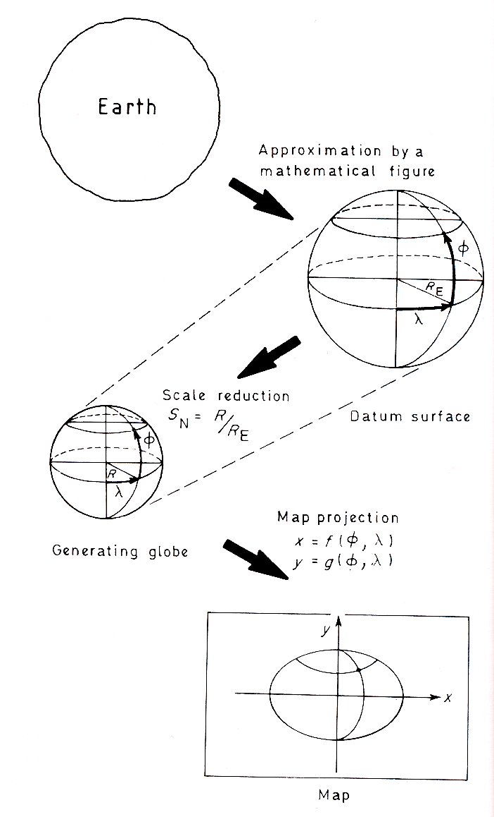

Fig 1.1 The map projection process: the sphere, approximated by a mathematical figure is reduced to a generating globe that is projected on a flat surface. (after Canters and Decleir 1989)

Different classes of projections
Usually, three main classes of projections are frequent in cartography. They are named after the developable surface onto which most of the map projections are at least partially geometrically projected. All three have either a line or a point of contact with the sphere: they are the cylinder, the cone and the plane. The advantage of these shapes is that, because their curvature is in one dimension only, they can be flattened to a plane without any further distortion (Iliffe 2000). Figure 1.2 shows the three possible types of map projections.
A cylinder is wrapped around the generating globe, so that its surface touches the Equator throughout its circumference. The meridians of longitude will all have the same length and be perpendicular to the Equator. The parallels of latitude are marked off as lines parallel to the Equator, around the circumference of the cylinder and spaced in such a way to preserve specific properties, described further. The final process consists of cutting the cylinder along a specific meridian yielding a cylindrical map. When a cone wrapped around the globe is cut along a meridian, a conic projection results. The cone has its peak -also called apex- above one of the two Earth's poles and touches the sphere along one parallel of latitude. When unwrapped, meridians become straight lines converging to the apex (commonly the pole), and the parallels are represented by arcs of circle. Their spacing along the meridians is defined to meet desired properties. An azimuthal projection results from the projection of meridians and parallels at a point (generally placed along the polar axis) on a plane tangent on one of the Earth's poles. The meridians are straight lines diverging from the center of the projection. The parallels are portrayed as complete circles, centered on the chosen pole. The uses of conic and azimuthal projections are generally limited for local and continental mapping.

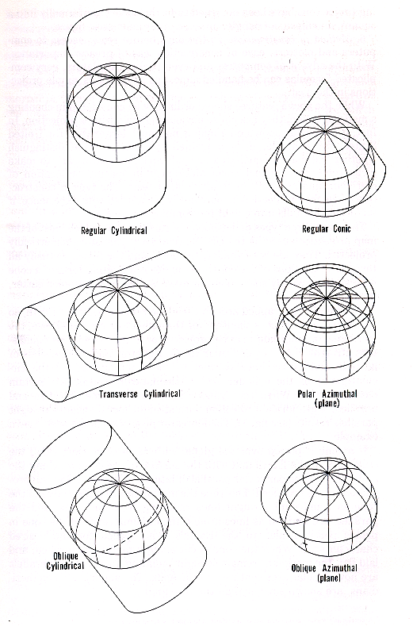

Fig 1.2. The Earth can be projected onto three main surfaces: the cylinder, the cone and the azimuthal.
This leads to cylindrical, conic and azimuthal projections respectively. (after Snyder 1987)

Although the construction's principles remain unchanged, the above developable surfaces can be oriented differently and cut the globe instead of touching it. When the cylinder or the cone is secant to the globe, it touches the surface at two lines of latitude. This greatly influences the distortion pattern, as will be discussed in the next section.
The aspect of a projection refers to the angle formed by the axis of the cylinder/cone and the Earth's axis. Usually the surface is tangent to the central or any meridian instead and leads to a transverse projection. But the angle can be between these two extreme values and resulting in an oblique projection, whereby meridians and parallels are not straight anymore. The same principle applies to the azimuthal projection, the contact lines being replaced by a contact point (Snyder 1987). Figure 1.3 and 1.4 illustrate a change of aspect for the cylindrical Mercator projection:
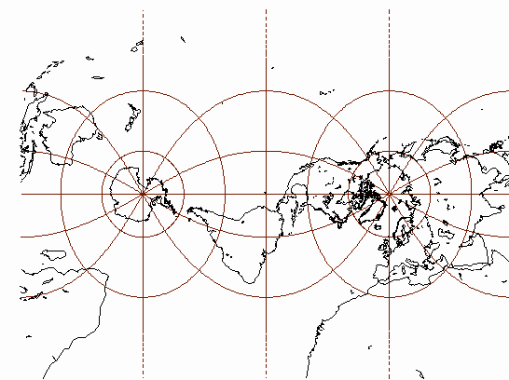
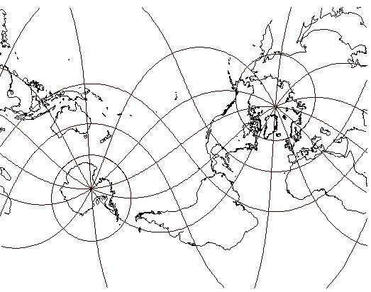

Fig 1.3. and 1.4. From left to right: the transverse aspect of the Mercator projection, and the oblique aspect
of the projection. Although the distortion pattern remains unchanged, the shape of the continental areas can highly be deformed. Compare with the Mercator projection (fig 3.8.). 30° graticule

Besides these three categories, other projections belong to similar classes, like the famous pseudocylindrical category, where the lines of latitude remain straight but where the meridians are curved instead. The Robinson's projection is a key example of this very important class. Other projections are said to be of the pseudoconic class when parallels are represented as concentric circular arcs and curved meridians. Pseudoazimuthal are very close to azimuthal projections, differing from a regular azimuthal projection by the shape of the meridians. Finally, the polyconic group results from the projection of the Earth on different cones tangent to each parallel of latitude.
While exploring the basics of map projections, it is also important to consider the choice of a central meridian (also referred as prime meridian). Usually, the projection is centered on Greenwich, which gives a European viewpoint. On a cylindrical projection, the choice of a central meridian is not so relevant, yet it is very significant on a pseudocylindrical, pseudoconic or polyconic projection since the continental areas that are located at the outer edges of the map are distorted. This is especially true for world maps characterized by elliptical, sinusoidal or other curved-shaped meridians. Figures 1.5 and 1.6 below show how the continental shapes on a Winkel-Tripel projection can be altered by choosing a different central meridian. A recent study by Saarinen (1999) shows that the majority of mental maps are eurocentric. On these maps, Europe is greatly exaggerated in detail and size, and mental deformations of continental areas at the edges are frequent.
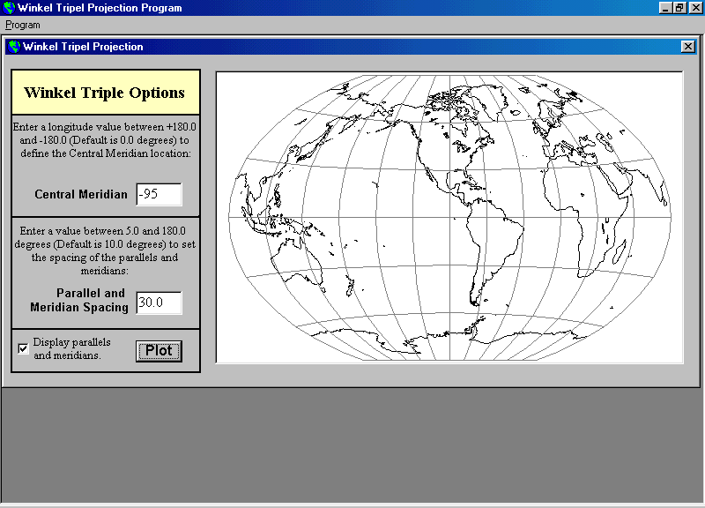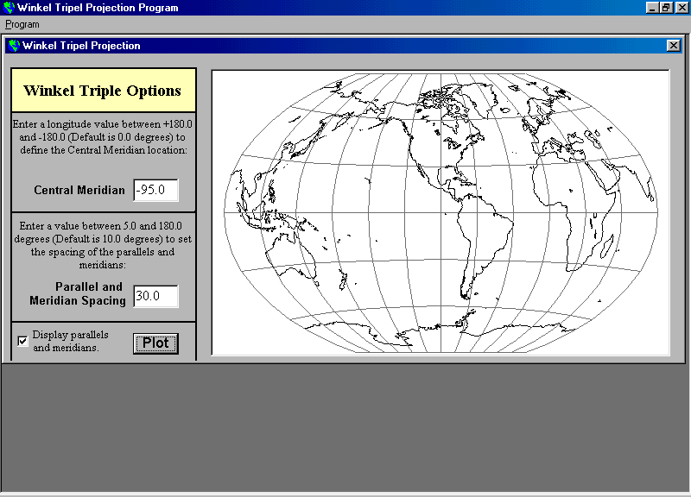
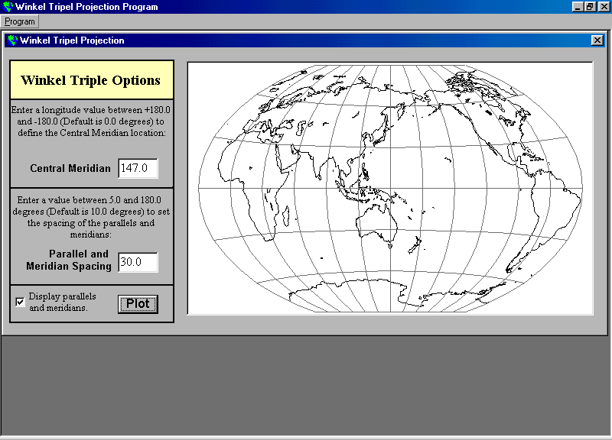

Fig 1.5 and 1.6 The choice of the central meridian (95°W on the left and 147°E on the right) on a Winkel Tripel projection modifies the shape and the orientation of America. 30° graticule

A general classification scheme seems necessary in order to gain accurate insight among the panoply of possible projections and assist the cartographer in his final choice for a projection framework. The most notable work is the all-inclusive classification of Tobler (1962) that divides map projections into four different categories based on the transformation formulas of the projection (eqn. [1]). As an alternative, Maling (1973) divided map projections into seven categories that eventually would give an adequate framework for the selection of a final world map (see Figure 1.7).
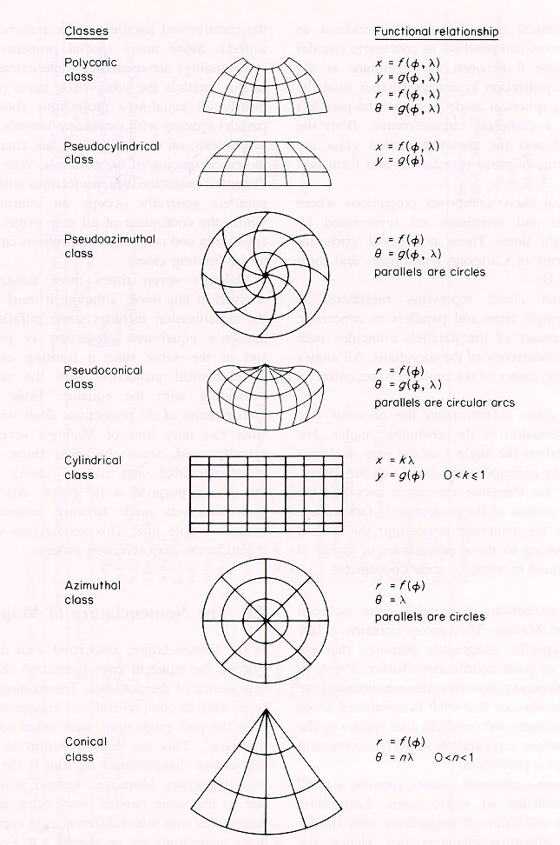

Fig 1.7 Maling 's classification scheme.
The projection should belong to one of the seven categories (after Maling 1992).

The main benefit of Maling's classification is the similar appearance of the projections within each category. A classification scheme provides a suitable basis that has a very practical value once a projection has to be selected for a particular purpose (Canters and Decleir 1989). The distortion characteristics of the different candidate projections for the final map should be combined with the classification process. This would reduce ambiguity upon similar projections and therefore improve the quality of the final projection choice.

Distortion
As we mentioned earlier, no single map projection can portray the Earth correctly without shearing, compression and tearing of continental areas. Subsequently, constant scale cannot be maintained throughout the whole map. By nature, world maps are more vulnerable to distortion than maps of lesser extent. Distortion on small-scale maps is therefore more perceptible, while less significant on a larger scale map. Aside from the qualitative evaluation, distortion can be quantified. Different approaches have been presented to study distortion on maps, the most remarkable being the Tissot's infinitesimal theory presented at the end of the nineteenth century. More recently, new distortion indexes have been devised that give a better insight of the overall projection on the map.

It is not the aim of this paper to give a mathematical development of distortion, but a few indexes need to be defined in order to get a general understanding of the distortion phenomenon. The book of Canters and Decleir wherefrom most of the formulas are derived, gives a far more detailed mathematical development. After Gauss, the scale distortion on a map projection is given by the ratio of a projected length ds determined by two points over the original length DS on the generation globe:
$m=\frac{\text{ds}}{\text{DS}}$ (3)
$m=\sqrt{\frac{\text{Ed}ϕ^{2}+2\text{Fd}ϕdλ+\text{Gd}λ^{2}}{(\text{Rd}ϕ)^{2}+(R\text{cos}ϕdλ)^{2}}}$ (4)
E, F and G are further defined as:
$E={\left(\frac{∂x}{∂ϕ}\right)}^{2}+{\left(\frac{∂y}{∂ϕ}\right)}^{2}$ $F=\frac{∂x}{∂ϕ}\frac{∂x}{∂λ}+\frac{∂y}{∂ϕ}\frac{∂y}{∂λ}$ $G={\left(\frac{∂x}{∂λ}\right)}^{2}+{\left(\frac{∂y}{∂λ}\right)}^{2}$ (5, 6, 7)
The x and y equations are derived to φ and λ respectively. m is equal to 1 everywhere on the globe, however, m cannot be equal to 1 on the map except along specific lines (contact lines) or at center points where the distortion is inexistent. The scale distortion m varies from point to point and fluctuates in every direction. In the case the developable surface has only one point/line of contact with the sphere, the distortion will increase away from point/line. When the developable surface cuts the globe, the area between the two standard lines is reduced (m<1) and stretched (m>1) away from the contact lines. When F is made equal to zero, the projection is said to be orthogonal, which means that parallels and meridians form a perpendicular network, like on cylindrical projections. Apart from the scale distortion m, two additional distortion indexes are defined here, namely the scale distortion h and k, respectively along a meridian(m) and along a parallel(p):
$h=\frac{{\text{ds}}_{m}}{{\text{DS}}_{m}}=\frac{\sqrt{E}}{R}$ (8)
$k=\frac{{\text{ds}}_{p}}{{\text{DS}}_{p}}=\frac{\sqrt{G}}{R\text{cos}ϕ}$ (9)
These two additional measures are very practical for the study of map projections. They give the distortion value for the parallel p and the meridian m at the point taken into consideration. A value greater than one results in a stretching of the line, a value less than one results in a compression.
An equidistant projection shows the length of either all parallels or meridians correctly. For an equidistant projection along the parallels, k=1 everywhere. An equidistant projection that shows h=1 preserves the length of the meridians. This is often the case for cylindrical projections. In no cases can h be equal to k and be equal to 1 at the same time, except for standard lines/point.
A conformal projection is a projection that gives the relative local directions correctly at any given point. It is obtained when the scale distortion is independent from azimuth or is the same in every direction:
$\frac{E}{R^{2}}=\frac{G}{R^{2}{\text{cos}}^{2}ϕ}$ (10)
F is made equal to zero, and h=k all over the map, however not equal to1.
An azimuthal projection shows the directions or azimuths of all points correctly with respect to the center of the projection. An azimuthal projection can be either equidistant, conformal or equal-area.
To obtain an equal-area projection, one must preserve elementary surfaces. A surface on the sphere should be equal to the same surface on the map:
${\text{DS}}_{m}{\text{DS}}_{p}={\text{ds}}_{m}{\text{ds}}_{p}\text{sin}θ^{'}$ (11)
DSmDSp can be calculated on the sphere as R2cosφdφdλ. The angle between the parallels and meridians on the map is θ'. dsmand dsp represent an infinitesimal length of a meridian and a parallel respectively on the map. DSm and DSp are the corresponding distances on the globe. The equal-are condition, is met when equation [12] is satisfied.
$\sqrt{\text{EG}−F^{2}}=R^{2}\text{cos}ϕ$ (12)
where the area distortion index is given by the ratio of the two terms cited above:
$σ=\frac{\sqrt{\text{EG}−F^{2}}}{R^{2}\text{cos}ϕ}$ (13)
Tissot's theory (1881) studied the distortion of infinitesimally small circles on the surface of the Earth. It applies to differential distances, no longer than a few kilometers on Earth. For a point on the Earth, the principle is to plot the values of m in all directions. The resulting geometric figure is called Tissot's indicatrix (from the French indicatrice de Tissot). Tissot stated that the angle formed by the intersection of two lines on the Earth could be represented on the final map either by the same angle or not. But he demonstrated it is possible to find two lines in every point of the Earth that, after the transformation process, will remain perpendicular on the map. These two directions are not de facto parallels and meridians. Along these two directions occur the minimum and maximum distortion. The major axis a is the direction of maximal distortion, while the minor axis b is the direction of minimal distortion (this value can be less than 1, which results in a compression). The a direction is placed parallel to the x-axis, b being parallel to the y-axis. a and b are defined as follows:
$a={\left(\frac{\text{ds}}{\text{Ds}}\right)}_{x}$ (14)
$b={\left(\frac{\text{ds}}{\text{Ds}}\right)}_{y}$ (15)
From what has been discussed before, a relation among h, k, a and b can be obtained:
$h^{2}+k^{2}=a^{2}+b^{2}$ (16)
The maximum angular distortion can also be derived from a and b according to the following equation. When 2ω is equal to zero for every point on the map, no angular deformation occurs and the projection is said to be conformal.
$2ω=2\text{arcsin}\frac{a−b}{a+b}$ (17)
On a conformal projection, a is equal to b and consequently the indicatrix is a circle everywhere on the map. The value of θ' in eqn. [11] can now be calculated from a and b as follows:
$\text{tan}θ^{'}=\frac{2\text{ab}}{b^{2}−a^{2}}$ (18)
However, the area of the indicatrix varies with the latitude and longitude. If there is any standard line, the area of the circle is equal to one. The area of the indicatrix remains the same everywhere (σ=1) when the projection is equal-area. The distortion index is then equal to:
$σ=\frac{π\text{ab}}{π}$ (19)
Note that ab=1 (equivalence) and a=b (conformality) are two mutually exclusive properties, yet a=b=1=ab on the standard lines. In other words, a projections cannot be equal-area and conformal at the same time, except on the reference lines. Tissot's theory is adequate to perceive the distortion of the projection at a glance. For instance, on the two maps below one can easily grasp the distortion characteristics (see Figures 1.8 and 1.9). However, in order to better evaluate the distortion among projections, it is recommended to compute the distortion values of angles, area or distances for different geographic locations and draw isolines connecting them (Robinson 1951). On the other hand, Tissot's theory is inadequate for describing distortions in the size and shape of continental outlines, as depicted on world maps (Peters, 1984).

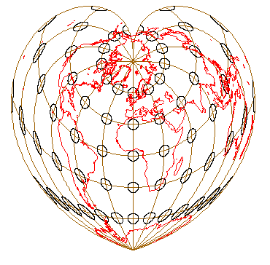
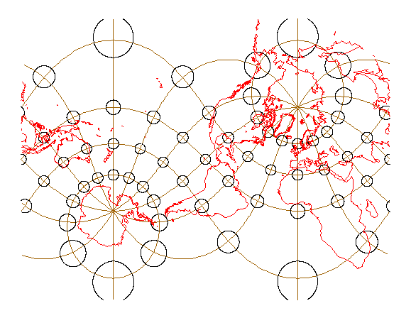

Fig 1.8 and 1.9 From left to right:

Tissot's indicatrices on the Bonne equal-area projection and on the oblique conformal Mercator. The indicatrices on the Bonne's projection show the same area everywhere, but their shapes are distorted according to the distortion pattern at that latitude/longitude. Distortion is very great along the meridians in the very high latitudes of the Southern hemisphere and along the meridians close to the outer edges. The indicatrices are equal on the central meridian, where ab=1=a=b. The indicatrices remain circles on the oblique Mercator's projection since it preserves angles. Nevertheless, they become bigger away from the centerline, which mean an increase of the scale distortion. The areal distortion for Africa and Alaska for instance is over exaggerated. 30°graticule

Before considering the different properties that a map projection can preserve, it is important to evaluate the distortion effect from the choice of another central meridian and another aspect/orientation. Although the distortion pattern and the distortion values calculated from the equation cited above remains the same, a change of central meridian alters the general outlook of the continental shape (see Figures 1.5 and 1.6). The prime meridian should be centered on the area of interest (Hsu 1981). For world maps, the choice is manifestly more ambiguous since there might not be a center of interest. In this case, the prime meridian is usually centered on Greenwich (0°). For almost every map in this paper, the projections are centered on this meridian.
The aspect of the projection does not make the distortion pattern and the values vary. However, in case the distortion is evaluated on continental areas only, the aspect and the choice of the prime meridian modifies the distortion values. Nevertheless, the continental shape is sometimes highly altered resulting in an unacceptable projection (see Africa on figure 1.9 for instance).
Before defining the problem, it remains fundamental to develop briefly the different special properties of a projection discussed above (equivalence, conformality, equidistance, azimuthal) and other geometric features that are characteristic of a projection. This should allow the GIS user to distinguish the differences among the supported projections better.

General and geometric properties
Canters and DeGenst (1996) consider the geometric and special (better referred as general) features to be imposed in order to better serve the purpose of the map and therefore act as the core of any map projection selection process. The most important geometric features are listed and briefly discussed. General features are stressed again, since they are crucial in the selection of a final suitable projection.

Geometric features

Outline of the map
The outline of the map influences the message the map communicates. A circular outline is said to give a good impression of the spherical shape of the Earth (Dahlberg 1991). A rectangular outline has the advantage that it fits fairly in the format of a piece of paper. Many critics have risen from different cartographic associations against the use of rectangular map projections, especially the Mercator's and Peters' projections. Robinson (1988) and the American Cartographic Association (1989) stress the misconceptions generated by rectangular grids: the Earth is not like a square: it is thus essential to choose a world map that portrays the roundness of the world better.

Symmetry of the map
The absence of symmetry in a map is often experienced as confusing and unattractive. Symmetry helps people to orient themselves better. The regularity of the graticule is an important aspect that needs to be considered as well. For instance, the Eastern and Western hemispheres are symmetric to the central meridian.

Representation of the Pole
The Pole can be represented as a line -projection with pole line- or as a point -pointed-polar projection. The first has the inconvenience of stretching polar areas in the E-W direction while the latter generates a very high angular distortion, especially in higher latitudes. Compromise projections such as pseudocylindrical projections can prevent this.

Spacing of parallels and meridians
On most projections, the spacing of the parallels highly influences the conservation of the equal-area property (Hsu 1981). An equal spacing of the parallels avoids extreme compression or stretching in the North-South direction. A decreasing spacing is often the guarantee to meet this criterion, at the cost of a severe compression of the polar areas. However, the spacing can be reduced and replaced by a stronger convergence of the meridians towards the poles.

Shape of parallels and meridians
Generally, the shape of the meridians and the parallels is taken into consideration to classify a projection. Straight parallels meeting straight meridians at right angles lead to a rectangular grid, belonging to the cylindrical class. Both meridians and parallels are circles on the globe, but at best can only be depicted as arcs of circles. Curved meridians converging towards the poles portray the continents at an angle from their original position. Especially on pseudocylindrical projections with sinusoidal meridians, the shapes of the continental areas close to the edges of the map are severely distorted. Curved parallels, when combined with curved meridians give the map-reader the impression that the Earth is round and not flat. Furthermore, the angle between meridians and parallels becomes smoother, which is more pleasing to the eye of the map-reader.

Ratio of the axes
Preserving a correct ratio of the axis of the projection may prevent an extreme stretching of the map in one of the two major directions and may lead to a more balanced distortion pattern. A correct ratio (2:1) presumes a length of the equator twice the length of the central meridian and generally yields to a pleasing map. This makes sense, since the longitude goes from -π (-180° or 180°W) to +π (+180° or 180°E) and the latitude from -π/2 (-90° or 90°S) to +π/2 (+90° or 90°N).

Continuity
The property of continuity, i.e. that the projection forms a continuous map of the whole world, is important in maintaining the concept that the Earth has no edges and that the study of the relationship of world distributions should not be confined by the artificial boundary of the map. This is very relevant for mapping continuous purposes, such as climatic phenomena (Wong 1965). No projections fully preserve complete continuity. However, interrupted projections (e.g. Goode Homolosine) have more discontinuities.

General features
General features include the properties preserved on a projection, such as the angles, areas, distances or azimuths (De Genst, Canters 1996). Respectively, the projection is said to be conformal, equal-area, equidistant or preserving azimuths.

Equal area property
On equal-area projection, all areas on the map are represented in their correct proportion, which is an essential criterion for the mapping of political, statistical or economical variables (Hsu 1981). As Tissot demonstrated, the use of the equal area property generally implies a high distortion of shape, since both properties are mutually exclusive. The equal-area property is very important for the display of density by dots. The projection process could yield a distorted shape, but as long as the area is preserved the density of the points will remain the same. This can be violated through the choice of a non equal-area projection that would enlarge areas. The dots would be scattered too much and therefore change the meaning of the map.
Nevertheless, it seems that the quality of equivalence is accorded somewhat greater significance that it actually warrants. As Robinson (1949) points out, the human eye is not particularly precise in its observation of irregularly shaped areas. Even a person very much aware of the sizes of the continents would barely be able to recognize a 15% error in the areal representation. Therefore, Robinson opts to disregard the automatic use of equal-area projections when it appears commonsense that improvement in the presentation of other properties might provide a better total representation than would strict equivalence.

Conformality
On a conformal projection, the angles measured around any point of the map are correct. This feature is of extreme importance for navigational and military purposes where the angles from two geographic locations must be preserved. The conformality property also shows application in mapping flow lines(Hsu 1981). It should be noted that the preservation of angles does not yield to the preservation of shapes.

Equidistance
An equidistant map projection indicates the absence of scale distortion and can only be achieved along specific lines or along some selected parallels. A secant cylindrical projection is already equidistant along two standard lines. The sinusoidal projection has all parallels equidistant (k=1 everywhere). A one-to-one equidistant map (that preserves the distance between two points along the shortest line connecting them) and a one-to-many projection (the distance between the center of the map and all the other points are preserved) are also possible.

Correct Azimuth
A projection showing azimuths correctly is an important feature in navigational charts and has an important application in representing radar ranges for instance (Hsu 1981). On azimuthal projections, all great circles that pass through the center of the projection will be represented as straight lines radiating from the center of the projection. The importance of this property has additionally been discussed by Gilmartin (1985) to display the route of a Korean airplane shot down on its way from Anchorage to Seoul. Twenty different maps showing the same purpose have been analyzed and it turns out that the message was hampered on a few of them, due to a weak projection choice.

Eumorphism
The name eumorphism connotes approximate true shapes of the continents. The distortion if shape is usually measured by a index developed by Boyce and Clarke. Although it remains possible to preserve true shapes at a local scale trough a conformal projection, it is impossible to obtain true shape representation of landmasses in world maps (Wong 1965).

In conclusion, it should be stressed that the properties exhibited on a projection do not automatically reflects in a better quality. A sinusoidal projection for instance is equal area and equidistant along the parallels and the central meridian but is totally unsuited for any purposes since it deforms continental areas too greatly. The final purpose of the map defines the properties the projection should preserve in order to better meet the original constraints defined by the purpose of the map.

Purpose statement
Map projections have been defined so that the reader can understand the objectives of this paper and what follows. The process of transforming the Earth onto a flat medium has been explained quantitatively as qualitatively, which includes the mathematical process of map transformation. Results from this transformation process are generally the conic, cylindrical and azimuthal projections. Other classes are possible such as pseudocylindrical, pseudoconic, polyconic, minimum-error and other miscellaneous types. Distortion has been reviewed, through the Tissot's indicatrix. Finally, geometric and special properties have been analyzed: how can specific map projections be equidistant along certain meridians, display the pole as a line and be equal area all over the map in the same time? Or what makes a map conformal, preserving local shapes properly?

It is important in this section to define the problem encountered for GIS users when dealing with map projections, which is central in this study. Study objectives, hypotheses and literature review are presented.

Objectives
Generally, it turns out that most textbooks and papers on map projections are more mathematical than qualitative. This is an important source of background information that serves the GIS user to grasp a good insight in the mathematical aspect of map projection, and to facilitate the selection process.
From the late eighties to the early nineties papers and textbooks have stressed the importance of automated cartography for the development of new small-scale projections. However, even for a GIS user with a respectable knowledge in computer programming it is difficult to fully incorporate these new hybrid projections into the -generally not flexible- software. It would be even more complex and time consuming to create a new projection that would perfectly fulfill the needs established by the map purpose(s). Most work on the selection of map projections is based on the classification of existing map projections, which is notable. However, a few authors have stressed the idea that instead of creating a new projection, transformation formulas of existing map projections could be modified, in order to limit the distortion over the area of interest. But even if this method seems less time-consuming, this modification is sometimes rather complex, and most GIS software does not necessarily support this customization.
Therefore, two tendencies emerge: on the one hand the user would select from a set of provided map projections the most suitable framework for the final purpose of his map. This technique is rather favorable from an economical point of view and furthermore less time-consuming. Nevertheless, this simple approach does not always yield the desirable projection, especially if the set of available projections is rather limited. On the other hand, the user could create his or her own projection starting from a set of given constraints or by customizing an existing projection. This approach is rather time-consuming, but results in a projection that would better fulfill the constraints imposed and guarantee a minimum visual distortion. Hence, it is important to study world map projections from a practical point of view. A directory that contains most of the current supported projections in GIS has been defined. Generally, the choice of projections is rather limited in desktop GIS, although wider in command-based GIS. Fortunately, most GISs include a translator extension that allows the user to project his data in a more suitable projection.

Every map has its own characteristics and is better suited for one purpose than for others. While an endless number of projections can be devised for any purposes, we concentrate our study on some well-known projections that have been adopted as general reference for mapping the world. Consequently, most of the projections supported by commercial GISs (i.e. ESRI Arc View 3.2., ESRI Arc View projection utility 1.0., ESRI Arc Info 8.0., Maptitude 4.0.3. and Map Info 4.5.) have been included in this directory (See Appendix A for an exhaustive list). The choice of the projections analyzed in this paper remains somewhat arbitrary, although most of them are reviewed in general cartography books. Throughout this paper, the characteristics of the selected projections are analyzed qualitatively and to a lesser extent quantitatively. This will gives the reader a good insight into the benefits and pitfalls of every projection for his final mapping purpose.

Geographical software gives the possibility to convert data instantaneously from one projection to another, but do not give the user much detail about the suitability of a projection for the final purpose of the map, which is what this paper intends to do. These systems do not support a broad choice of projections, nor do they provide the freedom to change parameters. Critical considerations are therefore presented to improve the quality of projection selection for GIS users.

Literature review
There is a substantial body of literature on the subject of map projections, and for each map projection described in this paper, a considerable number of papers are found in general geographic or cartographic journals. Although not exploited for this paper, it is not surprising to find a lot of German articles, as a considerable number of map projection were developed in Western Europe. The literature study for this paper starts through browsing the book from Snyder and Steward (1988), "Bibliography of Map Projections”, which is a considerable source of information. A few articles discuss map projection abuses, such as using Mercator for unreasonable purposes, but also for others (e.g. Van den Grinten), although to a less extent. In his book entitled "Flattening the Earth", Snyder (1993) reviewed the conception of existing projections since Ptolemeus. In this book, each map major projection is discussed. On the other hand, the book does not describe the suitability of the projections for mapping purposes.
The Master's thesis of Wong (1965) describes the use of map projections in the United States during the period 1940-1960. Critical considerations about the suitability of projections are given. Other general textbooks are of relevance for this paper: the books of Canters and Decleir (1989), Maling (1992) and Snyder (1987) are rather mathematical and have been useful for this paper. But unfortunately, the authors do not consider the GIS implications of map projections. They were certainly aware of the increasing automation of mapping software, but at the time most GIS software was not of great accessibility. Notably enough, Monmonier (1990) discusses how map projections have been mishandled in media, for political propaganda, which can greatly been used for the description of the benefits and drawbacks of every projection. The 90s have been characterized by progress in the field of computers, which has simplified plotting of map projections. Hence, the use and conception of new projections has been made easier, especially when mathematical computation was required. Minimum-error and tailor-made projections have been devised to suite general-purpose mapping (Peters 1984, Canters 1989, Laskowski 1991). The methods to quantify the distortion are based on the distance distortion and are not comparable with Tissot's theory.
With the improvement of remote sensing and aerial photography, acquisition of geographical data has increased extraordinarily, but has again confronted the geographer with the projection problem. Spatial data acquired in different projection frameworks need to be converted to a single and unique coordinate system in order to increase the ease of data transfer for GIS applications. Quite a lot of literature (Canters 1995, Goodchild 1991, Mekenkamp 1991, Maling 1992, Iliffe 2000) is available in recent cartographic and other GIS textbooks or journals.
Map projection selection has been discussed by Peters (1984), Snyder (1987, 1989), Kessler (1991), Mekenkamp (1991), Purnawan (1991) and De Genst (1995). All of them are very useful in assisting the GIS user in his final choice of a decent projection framework. De Genst approaches the selection process from a qualitative- mathematical aspect, allowing the user to modify the selected projection in order to better meet the constraints of his map.

Methods and limitations
It is the aim of the next four coming sections to analyze the general properties of the selected map projections. The three first sections have been divided according to the classification of Maling (1992): the first group deals with cylindrical projections, the second one with the emerging group of pseudocylindrical projections and the third with polyconic and pseudoconic projections. A last category has been added that reflects the growing importance of minimum-error map projections. The historical development is briefly discussed and a distortion analysis follows. Special properties, if any, are mentioned. An additional discussion explains the use or misuse of the projection. The quality of GIS applications can considerably be increased by a decent choice of projection framework. Based on the conclusions from the directory, current selection schemes are modified to improve the quality of the selection process.

It is not the aim of this paper to study map projections at a larger scale. The distortion generated on global scale maps is less on continental scale maps. Therefore, the impact of distortion is less important. For most of the countries, a very suitable projection low in distortion has been devised (e.g. Albers for U.S.A.). The ellipsoid fits the geoid of the continent to be mapped fairly well. The directory could be more extensive, but it is the goal of this paper to give some directions for the GIS users, not an all-inclusive study. In this framework, interrupted map projections (e.g. Goode's homolosine) have not been discussed because current GIS do not support them.

Selected map projections

Cylindrical projections
Until a few years ago, cylindrical projections were probably the most common types of world maps. Since many new non-cylindrical projections have been devised during the century, such as minimum-error projections, cylindrical projections have seen their use in atlases, school atlases and other textbooks decreasing. However, they remain very practical because their rectangular outline is unrelated to the smooth roundness of a sphere, but is often seen because its shape fits nicely in the common format of a printed page or poster (Dahlberg 1991). They are also easy to plot and very useful for locating geographic features, as parallels and meridians form a perpendicular grid. Cylindrical projections are ordered and discussed according to their general properties, going from equidistant to compromise cylindrical projections and from equivalent to conformal.

Distortion generated by cylindrical projections
Generally, cylindrical projections are the less suited type of map projections for general purpose since they show a considerable amount of distortion in the higher latitudes. They are characterized by one single line of zero distortion, also called standard line. This line corresponds to a great circle on the globe and is represented on the map by a straight line. The characteristic grid of a cylindrical projection is rectangular. In the normal aspect parallels and meridians form an orthogonal rectilinear grid. The poles are then represented as straight lines equal in length to the Equator, which coincides with the line of zero distortion (Canters and Decleir 1989).
It should be added that there is another case central to this paper, namely the secant case, where the cylinder, instead of being tangent to the globe, cuts it across two parallels. Instead of one single standard line, there are now two standard lines of zero distortion where the distortion increases away from the standard line(s). Between two standard lines, an East-West compression occurs resulting in a North-South stretching of the continental areas. Outside these two lines, the inverse distortion pattern is observed: polar areas are very much compressed in the North-South extent. Oblique and transverse cylindrical projections are not mentioned in this paper since their usage is limited to local and continental scales.

Plate Carrée projection
The Plate Carrée∗ is the simplest ever found and is still in use because of its ease to locate geographic features on the map. One of the characteristics of this projection lies in the spacing of parallels and meridians that is the same and hence considerably facilitates the construction of the graticule, which might have contributed to the propagation of the projection (Canters and Decleir 1989). Like every cylindrical projection, the parallels are equal in length and cross meridians at right angle. The transformation are given below.
$x=R(λ−λ_{0})$ (20)
$y=Rϕ$ (21)
x is a direct function of the longitude as y is of the latitude respectively. Parallels are equally spaced from the Equator towards the poles, as are the meridians West and East of the central meridian (see Figure 3.1).
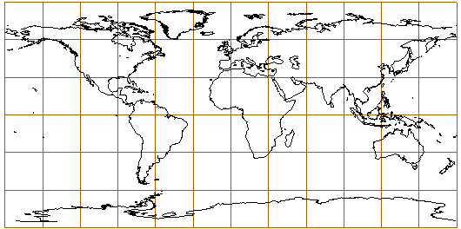

Fig 3.1. The world on the Plate Carrée projection. Central meridian 0°, 30° graticule.

Distortion
The standard parallel is the Equator (φ0) where no distortion occurs. All the meridians preserve their correct lengths, which implies that the projection is equidistant along the lines of longitude. All the other lines of latitude have the same length, which generates a considerable scale exaggeration of the parallels in higher latitudes, resulting in a severe E-W stretching of the continental areas. Subsequently, the angular and area distortions are characterized by the same distortion pattern (Snyder, Voxland 1989). Therefore, this projection is not recommended as a general-purpose world map.

Discussion
The Plate Carrée projection is best used for city maps, or other small areas with map scales large enough to reduce the obvious distortion. It is also a convenient projection when portrayals of the world or regions with minimal geographic data, such as index maps, are required. Other aspects of the Plate Carrée projection have been devised. The transverse case (where the central meridian becomes the Equator and inversely), better known as Cassini’s projection has largely been used for accurate topographic mapping (especially in France in the 18th century) and for large-scale mapping of areas near the central meridian, although today conformal topographic maps are preferred. It remained used however for large-scale maps of areas predominantly North South in extent. Used primarily for large-scale mapping of areas near the central meridian. This projection is neither conformal nor equal-area, but places itself as a sort compromise between the two end-members. No areal or distance distortion occurs along the central meridian, however it increases with distance from the central meridian.

Equirectangular projection
The Plate Carrée projection is a “limited case” of the equidistant cylindrical projection, because it has only one point of contact with the sphere at the Equator. The Equirectangular projection has two standard parallels (see Figure 3.2.). The final shape of the grid and therefore the general outline of the continents depends on the choice of the standard parallels, which lie symmetric about the Equator. Standard parallels far away from the Equator will result in a severe N-S stretching of the continental areas, such as Africa or South America. Parallels that are too close to the Equator generate an excessive E-W stretching in the higher latitudes. Transformation formulas are given below.
$x=R(λ−λ_{0})\text{cos}ϕ_{0}$ (22)
$y=Rϕ$ (23)

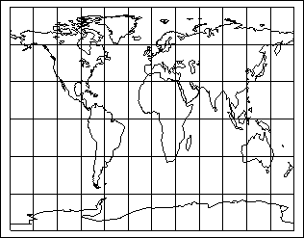

Fig 3.2. The Equirectangular cylindrical projection. Central meridian 0°, 30° graticule.

Distortion
The equirectangular projection is equidistant, which means that the scale along the meridians and the standard latitudes is correct. The grid is made of small rectangles, all equally sized. The meridians are equally spaced straight lines, more than half long as the Equator, whereas the spacing between the parallels is greater than between the meridians.

Discussion
Popular though equirectangular type of projection may have been during the Renaissance for the easiness of the construction, by the eighteenth century, many projections that were within the reach of cartographers were more attractive: hence its popularity declined (Snyder, Voxland 1989). By the 20th century, the use of the Plate Carrée and other equirectangular projections was almost non-existent for detailed geographic maps. But the simplicity of construction, some elements of scale preservation and increasing computer technologies gave this type of projection a role as an outline map, appearing of the 1980s as a quickly drawn base for the insertion of other data. The United State Geological Survey (USGS) used it for index maps to show the status of mapping of topographic quadrangles and the like (Snyder 1993).

Gall Stereographic projection
Gall, clergyman of Edinburgh, presented new cylindrical projections by the end of the 19th century that became popular partly because they could be more easily understood. He was prompted, like many others, by the desire for a world map that avoided some of the scale exaggeration of Mercator. Gall presented three projections: a stereographic, an orthographic and an isographic projection. The isographic projection, an equirectangular projection with standard parallels at ± 45° is not discussed in this paper. The stereographic projection presents shapes close to the Miller projection (see Figure 3.3.). The projection is probably the most suited for general-purpose maps (Snyder 1993).
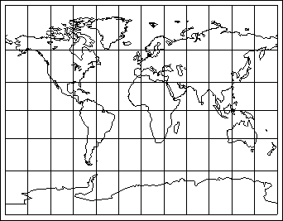

Fig 3.3. The Gall stereographic projection. Central meridian 0°, 30° graticule.

The equal-area cylindrical projection with two parallels as standard lines is a variant of the projection with one standard line. General transformation formulas are given by Decleir (1980):
$x=Rλ\text{cos}ϕ_{0}$ $y=R\frac{\text{sin}ϕ}{\text{cos}ϕ_{0}}$ (24, 25)
This projection is a secant projection of the globe on a cylinder, with two standard parallels at ± 45° symmetric about the Equator. Formulas are:
$x=R(λ−λ_{0})\text{cos}{\text{45}}^{0}$ (26)
$y=R(1+\text{cos}{\text{45}}^{0})\text{tan}\frac{ϕ}{2}$ (27)

Distortion
The Gall stereographic is neither conformal nor equivalent, but the projection shows a good general balance of distortion. Gall himself found that the geographical features and comparative areas were conserved to a degree that was very satisfactory. The projection, though inferior to Mercator's for navigation, is superior to it considering that it shows the entire world and does not devote map spare to the "grossly misrepresented regions" (polar areas). However, it never superseded the Mercator in America as did Miller's projection. Generally, for equivalent projections, standard latitude at ± 45° implies a considerable N-S stretching of the equatorial areas. With standard parallels at middle latitudes, the scale distortion the Gall projection shows a low scale distortion value over continental areas (Canters and Decleir 1989).

Discussion
The Gall stereographic, very similar to the Miller projection, is rather conformal than equal-area. Accordingly, it is suited for the display of flows, angles and azimuths, but also for the display of climatic data (Wong 1965). The stereographic projection has been used in the Time and Oxford atlases. The Gall stereographic projection has been modified many times to meet particular requirements. In the two atlases the meridians are curved differently to decrease the scale exaggeration near the poles (the Gall projection becomes pseudocylindrical instead).

O.M. Miller's projection
In 1942, O.M. Miller, member of the American Geographical Society, devised four new cylindrical projections. The then geographer of the U.S. department of State, S. Whittemore Boggs -also author of an equivalent projection-, asked Miller to study further alternatives to the Mercator, the Gall and other cylindrical world maps that were not suited for general world maps (Snyder 1993). The equidistant projection generally acts as compromise between these two projections, although the equidistant projection deforms significantly shape in the higher latitudes (Maling 1992). Other cylindrical projections were developed with intermediate properties that in all cases gave up conformality in order to reduce area distortion in the polar areas (Canters and Decleir 1989).
Under this set of conditions, Miller attempted to reduce areal distortion as far as possible. He found a system of spacing the parallels of latitude such that an acceptable balance is reached between shape and area distortion. The transformation formulas for his four projections are based on the Mercator projection. His third projection (see Figure 3.4.) is found the most suitable for S.W. Boggs' purpose. Transformation formulas are explained below.
$x=R(λ−λ_{0})$ (28)
$y=\frac{R}{0\text{.}8}[\text{lntan}(\frac{π}{4}+0\text{.}4ϕ)]$ (29)
where, like on Mercator x is a function of the longitude λ and y being derived from Mercator, but limiting the polar enlargement by dividing R and replacing φ/2 by 0.4φ.
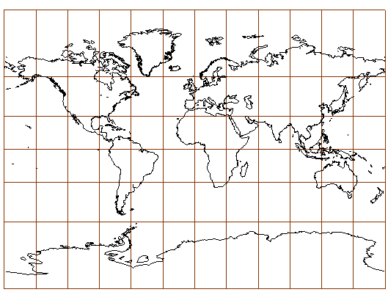

Fig 3.4. The Miller cylindrical projection. Central meridian 0°, 30° graticule.

Distortion
From the formula, it is evident that the spacing of the parallels is the same as if the spacing on Mercator was calculated for 0.8 of the respective latitude. As can been examined from the map, the deformation in the polar areas remains significant: for instance, Greenland does not look to be eight times smaller than South America. Distortion on the Mercator projection increases faster Northerly. If one limits the map to 80° of latitude, the projection becomes more acceptable. The Miller projection, like the Van der Grinten and Lambert projection in a circle received interests because their general deformation and resemblance are close to Mercator, yet not all conformal. Therefore we acknowledge these projections as good.

Discussion
The Esso war map, issued by the Oil Company in 1942, was the first publication of the Miller cylindrical projection. Government use followed the next year in the Army Map Service, showing lines of movement. Temperature and ocean currents and distributional data have been displayed on this projection as well (Wong 1965). The Miller cylindrical projection, like the Gall stereographic projection, approximates conformality rather than equivalence. Consequently, they are very suited for vector representation such as ocean currents, winds gradients…), air transport and ocean communication.

Gall-Peters equal area projection
Peters published his controversial map in 1972, convening a press conference at Bonn in 1973 for as many as 350 reporters. One year later, he gave a lecture in Berlin on his map to the German Cartographical Society where he compared his map with a dozen other well known map projections. He then reviewed different cylindrical equal area map projections, with standard parallels ranging from 30° to 55° of latitude (Loxton 1985).

The Peters equal-area representation of the world should rather be called "Gall's Ortographic projection", since it is the same projection Gall developed in 1885. Peters has heavily promoted "his" projection in spite of repeated statement in the cartographical literature stressing the lack of novelty (Snyder 1993). The Gall-Peters' projection is a secant cylindrical projection with standard parallels at ±45° (see Figure 3.5).

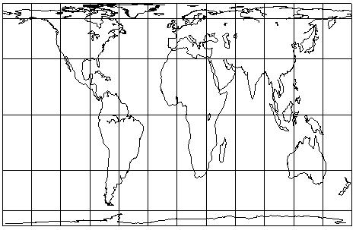

Fig 3.5. The Gall-Peters' projection centered on Greenwich. 30° graticule.
Standard parallels at ± 45°. Note the distortion in the polar areas.

It can be imagined that one standard line can be obtained by approaching the standard lines progressively to 0º of latitude, accordingly to the formula here below (Decleir 1980).
$x=R(λ−λ_{0})\text{cos}{\text{45}}^{0}$ (30)
$y=R\frac{\text{sin}ϕ}{\text{cos}{\text{45}}^{0}}$ (31)

Distortion
The selection of standard parallels at that latitude leads to an enormous stretching of the Equatorial areas: the bounding rectangles of equal area are increasingly compressed East-West and elongated North-South with the internal shapes correspondingly squeezed and stretched (Robinson 1985). By definition, an equal-area projection should give the possibility of comparing areas of different landmasses. The deformation of the shape and the angular distortion in the higher latitudes is so great that it is almost impossible to recognize countries in the higher latitudes.

Discussion
Peters adopted the promotional strategy of first asserting that Mercator's projection became the basis of the global map that formulated man's concept of the world; the projection was overused for whatever kind of purposes other than navigation. There he is definitely right. But Mercator himself never developed his map for other purposes than navigation (Snyder 1993). Balthasart (1935) already give some comments in favor of the Gall orthographic projection. He pointed out that during the early twentieth century, the Mercator projection was still very popular, even for display purposes that require the equal-area property. Since on both projections the meridians and parallels cross at right angle and hence form a perpendicular network, and since the main directions can easily be identified, the equal-area projection should prevail.
Peters stated that Mercator's projection remains highly influential in "shaping" people's view of the world: most of us, if asked to draw a map of the world from memory would roughly reproduce the Mercator's projection (Kaiser 1987). He also pointed out that the Mercator projection had the capacity to represent constant bearing angles as straight lines, but that this property was not applicable in the Polar areas since the poles themselves can not be represented (Loxton 1985). He finally added that the Mercator's projection was the only available map of the world, that it is euro-centered, that third world countries are shown disproportionately smaller in area than those in high latitudes, and that we need an equal area map to challenge our attitudes and prejudices.
Unexpectedly many volume users like the United Nations, school and colleges, churches and Third World action have adopted this projection. Peters claimed that his projection is the only correct representation of the world and that all other projections should all be removed from atlases and other school atlases (Kaiser 1987). Although most GIS applications can be projected with Peters, this projection, like the Lambert equal-area should be disregarded. Equal-area cylindrical projections distort shapes too excessively; hence the message the map is meant to communicate is lost.

Behrman equal-area projection
Behrman, in 1909, compared the distortion characteristics from some equal-area projections. Combining Tissot’s and Gauss’s least squares principles, he calculated the weighted mean of the angular distortion by drawing lines of equal distortion on the map and measuring the area between each two adjacent lines. He concluded that a minimum mean of maximum angular deformation was reached when the standard parallels are chosen at latitude of 30°. Maximum angular distortion is apparent in the very high latitudes (Canters and Decleir 1989). He therefore devised a secant equal-area with standard parallels at 30°. The meridians remain equally spaced, like in every cylindrical projection, while the parallels are unequally spaced straight lines, farthest apart near the Equator. As can be derived form the equation, the spacing between them decreases after 30°North and South polewards (the sinus function increases rapidly for values between 0° and 30°), in order to maintain equivalence (Snyder, Voxland 1989).
$x=R(λ−λ_{0})\text{cos}{\text{30}}^{0}$ (32)
$y=R\frac{\text{sin}ϕ}{\text{cos}{\text{30}}^{0}}$ (33)
If the central meridian is Greenwich, x is then a simple function of the longitude, cos φ0 , which is a constant. The spacing of the parallels y will decrease with increasing latitude.

Distortion
The Behrman projection shows a very low mean angular distortion for an equal-area projection, but cannot prevent extreme scale exaggeration near the edges of the map. The scale is too small along the Equator; too large outside the standard parallels polewards. There is no distortion of area, but to preserve the equivalence all over the map, continental shapes are altered and therefore limit the use of this map as a general-purpose map (see Figure 3.6).
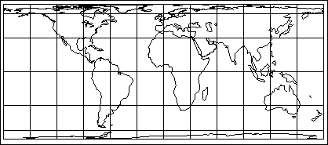

Fig 3.6. The Behrman equal area projection with standard parallels at ± 30°
Centered on Greenwich, 30° graticule.

Discussion
Behrman developed his projection a few years after Gall with the same idea, namely to counteract the influence of the Mercator projection. When comparing Mercator and Behrman, it is obvious that the Behrman projection is to be preferred for world mapping purposes. Unfortunately, the standard parallels being so close to the Equator, the overall shape distortion in the middle and higher latitudes is so significant that the use of this projection as a reference map should be rejected, although Behrman’s projection is useful for mapping tropical and equatorial areas (Decleir 1980). In these regions, the continental shapes stay close to the original. The Behrman projection is offered in most GIS/mapping package; only the central meridian can be changed, the other parameters being pre-defined.

Lambert equal-area projection
Lambert presented seven original projections, in one paper, several of them of considerable importance. The outstanding ones are the Lambert conformal conic (used as a reference map for the US), the transverse Mercator and the Lambert azimuthal equal-area. The cylindrical equal-area projection discussed here is named after Lambert, although probably developed by Archimedes (Snyder 1993). This projection, rather simple, is a limiting case of the cylindrical equal-area projection where the two standard parallels coincide with the Equator. All the parallels and meridians have the same length (see Figure 3.7).
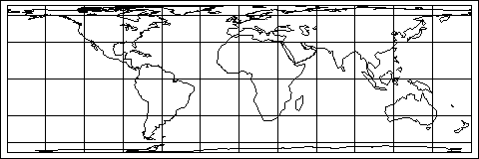

Fig 3.7. The world on the Lambert equal area projection centered on Greenwich.
The standard parallel is the Equator. 30° graticule. Note that the deformation of
the polar areas is greater than on the Gall-Peters' projection.

The x and y coordinates are respectively based on the longitude and latitude. Only the degrees of latitude becomes noticeably smaller towards the poles, and endlessly small at the pole. Transformation formulas are given below.
$x=R(λ−λ_{0})\text{cos}0^{0}$ (34)
$y=R\frac{\text{sin}ϕ}{\text{cos}0^{0}}$ (35)

Distortion
The Equator is the free of distortion. The polar regions are characterized by an extreme N-S shape compression and scale distortion. The equation for y involves that the zones of the Earth from the Equator to the poles increase their spatial content as the since of the latitude.

Discussion
The Lambert equivalent projection is not appropriate for general-purpose maps of the world whereas it is suited for the mapping of narrow areas extending along the central line.

Mercator conformal projection
Mercator was born Gerhard Kremer in Ruppelmonde, Flanders (then in the Netherlands) in 1512, but he latinized the name (kramer is Dutch for “peddler” and mercator is Latin for “merchant”). He moved to Duisburg, Germany, where he presented his cylindrical projection in 1569 (see Figure 3.8.), but also prepared numerous maps and terrestrial and celestial globes. Mercator’s chart was published in 1569 (ad usum navigantium) and became widely known among geographers by its inclusion the following year in the Theatrum orbis terrarum, a great atlas issued by Ortelius (Decleir, Canters 1985).

At that time, geographers had three main preoccupations when developing new representations of the world (Martin, James 1993):
Firstly, to spread on a plane the surface of the sphere in such a way that the positions of places correspond on all sides with each other both in so far as true direction and distance are concerned and as concerns correct longitudes and latitudes, and that the forms of the parts should be retained. To be used for navigation, parallels and meridians should cross at right angle, but should not converge toward the poles (e.g. not like a conical projection). Secondly, to represent the positions and the dimensions of the lands as well as the distances of places, as much in conformity with very truth as it is possible so to do. Finally, to show which are the parts of the universe that were known to the ancients and to what extent they knew them.
Mercator wanted to produce a world chart on which the correct representation of any rhumb line would be a straight line on his map. In order to keep the rhumb line straight, it is required that all meridians be a family of parallel straight lines and the parallels of latitude also be a family of parallel straight lines intersecting the meridians at right angles. To ensure the conformality, the spacing of the parallels was in a certain way made progressively larger away from the Equator toward the pole (the pole itself can not be represented). The y coordinate is a logarithmic function of the latitude. The parallels on the Mercator projection are stretched in the higher latitude to ensure the conformality (their spacing increases rapidly). The pole itself cannot even be represented (because the pole equals π/2, y becomes infinite).

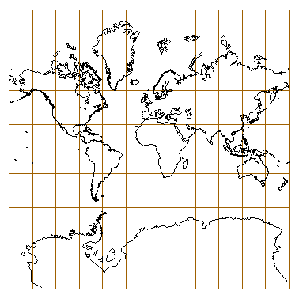

Fig 3.8. The Mercator conformal projection limited ± 85°.
Central meridian 0°. 30° graticule.

Transformation formulas are as follow.
$x=R(λ−λ_{0})$ (36)
$y=R\text{lntan}(\frac{π}{4}+\frac{ϕ}{2})$ (37)

Distortion
Mercator's projection is conformal, which means that the angles on the map are preserved as they are on the generating globe. Conformality also means that shapes of all small countries and seas are preserved. The scale factor along the meridians on the Mercator projection is a function of sec φ. At latitude of 60°, the scale factor is 2.000 in all directions.
Technically, the enormous areal exaggeration towards the poles makes the projection totally unsuited for general-purpose world maps. The American Cartographic Association (1989) claimed that the Mercator's projection is seen as being true by map users, because it highly distorts areas. It seems that people “believe” more in a greatly deformed map than in a minimum-error projection; greatly deformed maps seem to be a good medium to convey messages. So, in spite of the limitations of this projection, it still dominates the market. The Mercator projection remains highly influential in “shaping” people’s view of the world. It is largely responsible for many geographical misconceptions, e.g. the misleading appearance of the polar areas. Most of us, if asked to draw a map of the world from memory, would roughly reproduce the Mercator. Majella Gauthier (1991) points out how straight lines and distances on a Mercator can be very misleading. Elections were held in New Caledonia, October 1988 and a map showing straight lines and distances to France, Australia, Tahiti, Japan and the United States was published in a French newspaper Ouest-France. It turned out that the distances were calculated using the straight lines connecting New Caledonia and the listed countries. This is a major error since the distances should be calculated along the great circle connecting two geographic locations. The same example applies for a traveler flying in the middle and higher latitudes (see Figure 3.9.). From Oslo to Anchorage someone would think that the thicker line is the shortest way between the two cities. This is caused by the two-dimensional perception of the Earth. Most of us conceptualize our mental perceptions of the world through daily maps. But the length of the parallels decreases towards the poles and when looking on a globe, it is instead shorter to fly nearby the poles from Oslo to Anchorage. Straight lines on a gnomonic projection depict great circles. The shortest way between two geographic locations is therefore the line between these two points (see Figure 3.10.). Unfortunately, the gnomonic projection excessively distorts shapes. It is recommended for comparison with the Mercator and plotting long-distance courses of ships and airplanes. An orthographic azimuthal projection could be used instead with its center on one of the two locations or lying on the line connecting these two points (see Figure 3.11.). Such projections have been practical for the last 30-40 years because they distort continental shapes less.
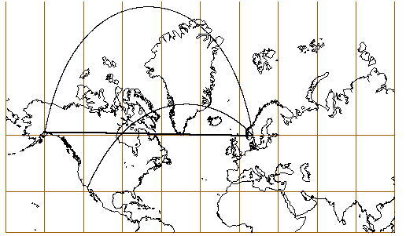

Fig.3.9. Mercator projection centered 60°N, 35°W. 30° graticule.
The curved lines represent great circles from Oslo to Anchorage and San Diego.
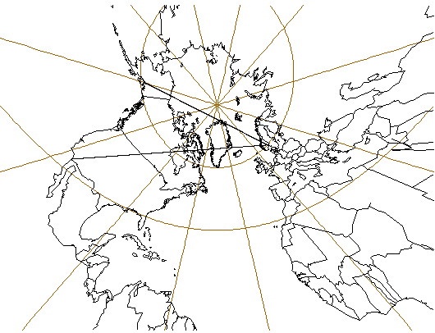
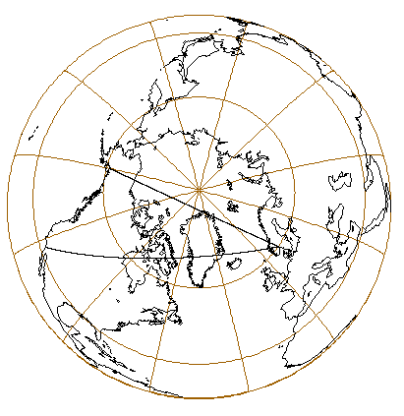

Fig 3.10. and 3.11. From left to right: the gnomonic projection centered 60°N, 47°W and the orthographic projection centered 80°N, 45°W. 30° graticule. Great circles from Oslo to Anchorage and San Diego are represented as straight lines on the gnomonic projection and are slightly curved on the orthographic projection. Note that the continental deformation is less on the orthographic projection.

Discussion
Although frequently used as the reference map in atlases, the Mercator projection disappeared in most atlases during the 17th and 18th centuries. It appeared again in Dutch atlases of the early 19th century (Decleir, Canters 1985). Although its use has diminished in the latter part of the twentieth century, it is still highly popular as a wall map apparently in part because, as a rectangular projection, it fills a rectangular wall space with more map, and clearly because its familiarity breeds more popularity. Its common use for world maps is very misleading, since the polar areas are represented upon a very enlarged scale and makes it totally unsuited in atlases (Snyder 1993). However, Mercator developed his projection for navigational purposes and achieved great prominence in the era of sea exploration following its development. Because of its reputation, it also becomes popular for geographic maps
In 1990, Monmonier described how this projection could be powerful to convey wrong messages. During the cold war period, the projection was greatly used for political propaganda. The former Soviet Union for instance is represented as almost twice as large as Africa, while Africa is 11.6 million square miles and the Soviet Union 8.7 million. This projection was also used to show the extension of the British Empire with an over exaggerated size of Canada too large. Probably the most significant example of the error this projection generates is the relation between Greenland and India, where Greenland is represented as four to five times larger than India while the Asian country is 38% larger. South America is more than 8 times larger than Greenland, but on Mercator’s projection they cover the same area. Other relevant examples are the relation between Sweden and Madagascar: Madagascar is 42% larger than the Scandinavian country, but who would be able to derive that from the Mercator projection (Kaiser 1987)?

Conclusion
While a Mercator projection extremely distorts the higher latitudes to preserve the conformality, an equal-area projection stretches Equatorial latitudes and compresses higher latitudes to ensure the equivalence. Those two examples of “extreme” rectangular projections show that they are totally unsuited for general purposes (Robinson 1988). Where projections are greatly distorted, they have a severe lasting effect on people and lead many geographical misconceptions. So, it seems that both types should be disregarded. If an equal-area cylindrical map projection is to be used, Behrman's version is to be preferred. The Miller and the Gall stereographic projections preserve shapes better. However, if the user has the possibility to select another projection framework, the choice should be oriented to pseudocylindrical projections instead.

Pseudocylindrical projections
Distinguished from cylindrical projections by curved meridians, but sharing the pattern of straight parallel of latitude, the pseudocylindrical type of projection was about to become a favorite design concept for new projections as the 20th century began (Snyder 1993). Most of them were devised during the nineteenth and twentieth century, and have gradually replaced the cylindrical projections in most textbooks and atlases. As mentioned before, a disadvantage of the cylindrical projections is that they show all parallels as the same length and therefore stretch the polar areas excessively. Pseudocylindrical representations reduce this deformation by reducing the length of the parallels with increasing latitudes (Robinson 1988). On some projections, the pole will be represented as a point (these are called pointed polar projections like Mollweide and Boggs) or as a line commonly half the length of the Equator (e.g. Eckert, Wagner, McBryde, Robinson).

Distortion generated by pseudocylindrical projections
Generally, pseudocylindrical projections are more suited for general-purpose maps than cylindrical projections in terms of distortion. The areal distortion increases away parallel to the equator. Pointed polar pseudocylindrical projections have the inconvenience of compressing landmasses of high latitude toward the central meridian. Furthermore, pointed-polar projections are less suited for world maps because of the considerable angular distortion near the edges of the maps and especially in the higher latitudes; pseudocylindrical projections with a pole line avoid this. Equal area pseudocylindrical projections with a pole-line severely compress the polar areas because of the decreasing spacing of the parallels towards the poles.

Eckert IV (equal-area)
In the early twentieth century, Eckert devised six map projections (I, II, III, IV, V and VI), the even numbers being the equal-area versions of the odd numbers: The two first projections have rectilinear meridians, the third and fourth elliptical meridians and the two last are characterized by sinusoidal meridians. For instance, Eckert IV is the equivalent version of Eckert III, where the general outline and the graticule remain the same but only the spacing of the parallels decreases towards the poles to ensure equivalence.

Eckert I and II, also called trapezoidal projections from their general outline, show too much of distortion and therefore are not considered in this section. The discontinuity of meridians at the Equator yields a considerable distortion and leads to an unpleasing appearance of the Equatorial areas (Canters and Decleir 1989).

Eckert IV (see Figure 3.12.) is the equal-area version of Eckert III, which is the arithmetic mean of the Apianus' projection and the cylindrical equidistant projection. Eckert IV has a pole line half the length of the Equator. Both projections (III and IV) are similar in appearance but on Eckert IV the distance between the parallels decreases with increasing latitudes to ensure the equal-area property (Snyder 1993). Transformation formulas are as follows:
$x=2R\frac{(λ−λ_{0})(1+\text{cos}θ)}{\sqrt{4π+π^{2}}}$ $y=2R\sqrt{π}\frac{\text{sin}θ}{\sqrt{4+π}}$ (38, 39)
$θ+\text{sin}θ\text{cos}θ+2\text{sin}θ=\frac{(4+π)(\text{sin}ϕ)}{2}$ (40)
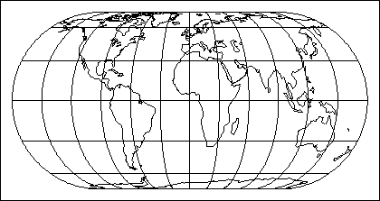

Fig. 3.12. The world on an Eckert IV equal-area projection with elliptical meridians.
Central meridian Greenwich. 30° graticule.

Distortion
Behrman's study indicated that Eckert IV has a very low mean angular distortion for an equal-area projection (Snyder 1987). On the other hand, the equal-area variant of Eckert III yields a severe stretching of the Equatorial areas (although more favorable compared with Gall-Peters) and compression in the higher latitudes. Continental areas at middle latitudes are characterized by a low distortion. This projection is less suited than other equal-area projections with a higher mean angular distortion. Eckert VI seems preferable.

Discussion
Eckert IV distorts equatorial and polar areas too greatly in order to be considered as a general-purpose map, although it is suitable to portray the middle latitudes. But for this purpose, conical projections and other transverse aspects of cylindrical projections seem much more appropriate. Eckert IV has been used in a few American atlases, textbooks, in the national Atlas of Japan and by the National Geographic Society on a sheet map (Snyder 1993). It is recommended for land distributional data, climatic purposes and, to a less extent, physical phenomena (Wong 1965).

Eckert VI (equal-area)
Eckert VI (see Figure 3.13.) is probably the most famous projection invented by Eckert (1906). It is the equal-area variant of Eckert V, which is the arithmetic mean of Sanson's pseudocylindrical (Sinusoidal projection) and the cylindrical equidistant projection (Plate Carrée). It shows a 2:1 ratio of the axes (the length of the central meridian is half the length of the Equator) and a pole line half the length of the Equator.

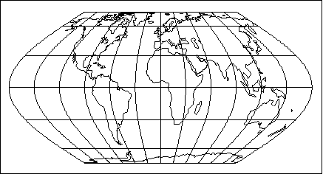

Fig. 3.13. Eckert VI equal-area projection.
Central meridian Greenwich. 30° graticule.

The meridians are curved, characterized by a sine function (Canters and Decleir 1989). The decreasing distance between the parallels with increasing latitude is not as much as on Eckert IV, which leads to a more satisfying result. Transformation formulas are as follow:
$x=R\frac{(λ−λ_{0})(1+\text{cos}θ)}{\sqrt{2+π}}$ $y=2R\frac{θ}{\sqrt{2+π}}$ (41, 42)
$θ+\text{sin}θ=(1+\frac{π}{2})(\text{sin}ϕ)$ (43)

Distortion
It is common for pseudocylindrical equal-area projections to have a greater distortion in the equatorial regions than do non-equivalent projection. The curvature of the meridians plays a major role in the shape of the continents and the general distortion over the continental areas. Sinusoidal meridians, as on Eckert V and VI give rise to higher angular distortion than elliptical meridians. The sinusoidal curve is steep and leads to a compression near the edges of the map.

Discussion
The Eckert VI projection is available in most GIS packages and is practical for portraying statistical and demographic data. It is also appropriate to portray data for other purposes such as physical phenomena, land use and economic development (Wong 1965). The pole line avoids a compression of the polar areas close to the central meridian. Continental areas at the higher and lower latitudes are preserved and give this map a pleasing outlook. Eckert VI is the basis for climate maps in the European-prepared but US-distributed Prentice-Hall world atlases of about 1960.

McBryde-Thomas Quartic equal-area projection
McBryde and Thomas presented five new pseudocylindrical projections in 1949 for world statistical maps in a U.S. Coast and Geodetic Survey publication. While McBryde provided the concepts, Thomas developed the mathematics. The equal-area flat polar quartic projection (see Figure 3.14.) is the fourth projection and the one that received the most attention. The meridians are curves of the fourth degree, which leads to a better representation of the polar regions than in the flat-polar regions with sinusoidal and parabolic meridians. Transformation formulas are given below.
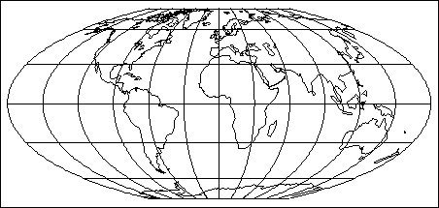

Fig 3.14. The McBryde-Thomas equal-area projection..
Central meridian 0°, 30° graticule.

$x=R(λ−λ_{0})\frac{[1+\frac{2\text{cos}θ}{\text{cos}(θ/2)}]}{\sqrt{[3\sqrt{2}+6]}}$ $y=2\sqrt{3}R\frac{\text{sin}(θ/2)}{\sqrt{2+\sqrt{2}}}$ (44, 45)
$\text{sin}(\frac{θ}{2})+\text{sin}θ=(1+\frac{\sqrt{2}}{2})\text{sin}ϕ$ (46)

Distortion
The shortening of the pole line (one third of the Equator) reduces the N-S elongation in the lower latitudes (especially the Equatorial areas), which is typical for equal-area pseudocylindrical projections with a pole line half length of the Equator. The correct ratio of the axes is almost preserved (2.22:1). Distortion is severe near outer meridians at higher latitudes, but less than on the similar pointed-polar projection, which make this equal-area projection a suitable world base map.

Discussion
The projection can be interrupted. Most desktop-GISs do not support this projection, but usually offer the conversion possibility, such as in ESRI Arc View projection utility.

Sinusoidal equal-area projection (Sanson)
The sinusoidal projection (see Figure 3.15) combines some important qualities with simple construction. It has been named after Sanson and Flamsteed (17th century) since they used it frequently, although Jean Cossin (France) developed the graticule. It is a limiting case of the Bonne's pseudoconical equal-area projection, the Equator being the standard latitude. The meridians (cosine curves) are marked off along each parallel (equidistant straight lines) at their true distances (Canters and Decleir 1989). Transformation formulas are given below.
$x=R(λ−λ_{0})\text{cos}ϕ$ (47)
$y=Rϕ$ (48)

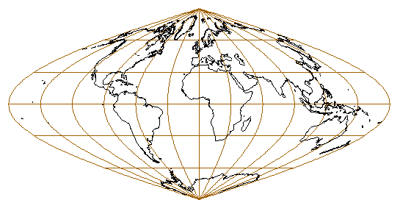

Fig 3.15. The sinusoidal equal-area projection..
Central meridian 0°, 30° graticule.

Distortion
The sinusoidal projection should be avoided for world maps because of the angular distortion near the edges of the map, especially in the higher latitudes. This is generated by the sinusoidal nature of the meridians (compressed polar areas). Since the shape of the Equatorial areas is preserved, this map might be acceptable for statistical mapping because of its equal area properties. But the compression and the angular distortion are so great that this map leads to many geographical misconceptions. When the user looks closely at the map, Alaska seems situated to the right of California, and he will also notice the orientation of Australia. This effect is engendered by the directional distortion of the meridians and the choice of the prime meridian.

Discussion
The sinusoidal projection has been used frequently as a parent projection for the development of other pseudocylindrical projections, such as Wagner, Eckert and McBryde (Snyder 1993). This projection is suited to portray continental areas, especially with a N/S extent such as Africa and South America. According to Wong (1965), the sinusoidal projection is one of the most popular projections for land distributional data. All GIS packages support the sinusoidal projection, maybe because of its ease of construction and its common use for statistical mapping.

Mollweide equal-area projection
Until 1805, Sanson was the only pseudocylindrical projection with important properties. Then Mollweide announced an equal-area world map projection (see Figure 3.16.) that is aesthetically more pleasing than the sinusoidal because the world is represented in an elliptical outline in a 2:1 ratio and the meridians are all equally spaced semi ellipses (Snyder 1993). It assumes that the total area of the bounding ellipse equals the area of the generating globe. Transformation formulas are as follows:
$x=R(\frac{2\sqrt{2}}{π})(λ−λ_{0})\text{cos}θ$ $y=\sqrt{2}R\text{sin}θ$ (49, 50)
$2θ+\text{sin}2θ=π\text{sin}ϕ$ (51)
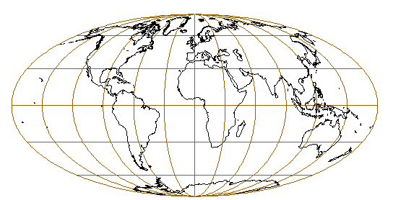

Fig 3.16. The Mollweide equal-area projection.
Central meridian 0°, 30° graticule.

Distortion
The distance between the parallels decreases with increasing latitude to ensure the equal-area property. There is no discontinuity at the poles because the world appears within an ellipse. The Mollweide's projection lends itself very well to the development of transverse and oblique aspects. A change of aspect does not alter the distortion pattern of the projection but only repositions it with respect to the surface of the Earth.

Discussion
The Mollweide projection lay relatively dormant until J. Babinet popularized it in 1857 under the name homolographic. It is the pseudocylindrical projection that received the most attention in the 19th century. It appeared in some atlases of the 19th century for numerous thematic features. It is more suited than the sinusoidal to show distribution of geographic and climatic phenomena. The Atlantis projection is the oblique case of the Mollweide's projection. The projection is available in most GISs as a base map for statistical data.

Robinson's projection
The Robinson projection (see Figure 3.17.) is neither conformal nor equal area. Named after its inventor, A. H. Robinson, it was especially designed for general-purpose world maps. The motivation behind this lied in the fact that the Rand McNally company, a major U.S. mapmaker, after considerable analysis of their needs around 1974, determined they required a new map projection.

Originally, there was a set of given constraints that the new projection had to fulfill; most relevant were that the major continents should have the least possible appearance of shearing and the least possible apparent change of scale, that each continent should appear to be approximately its correct relative size and that the new projection should minimize the possibility of inducing lasting erroneous impressions, such as might result, for example, from the marked variation in area scale of the conventional form of Mercator's projection (Robinson 1974). Within this context, the projection was developed from a perceptive approach by an iterative plotting process that was repeated until the shapes of the landmasses, with exception of the higher latitudes, were as realistic as they could be (Canters and Decleir 1989). Transformation formulas are given below:
$x=0\text{.}\text{8487}\text{RX}(λ−λ_{0})$ (55)
$y=1\text{.}\text{3523}\text{RY}$ (56)
Originally, Robinson did not devise any transformation formulas. X and Y have to be interpolated from the following table.

Table 1: X and Y values given by latitude at 5°increment.

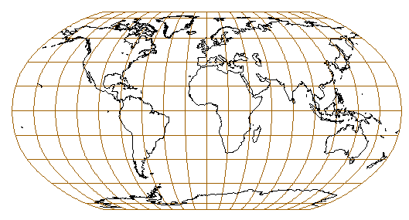

Fig 3.17. The Robinson projection adopted by the national geographic Society.
Central meridian 0°, 30° graticule.

Distortion
The Robinson projection is very pleasing to the eye, especially because at the center there is little deformation and distortion, but there is still a size exaggeration and shape distortion in the high latitudes and polar regions (McLeary 1989). Standard parallels are close to ±38°. The distortion of continental shapes in these latitudes remains acceptable from a perceptive point of view. It is then a good compromise that minimizes the distortion of shapes. The orthophanic (right appearing) has a less lasting and influential effect on people’s perception of the world.

Discussion
The National Geographic Society adopted this map projection in 1988, replacing the former polyconic Van den Grinten, mainly because the sizes of the continents on the Robinson projection were more realistic (Snyder 1993). The Van den Grinten projection with its circular outline distorts the polar areas so greatly that on most world maps they are not even represented. If only a small percentage of the National Geographic subscribers use the map and organize their personal "mental map" using Robinson's structure, then more people will have a more decent and accurate image of the relative sizes of continental areas on the surface of the Earth (McLeary 1989). The Robinson projection takes the position that a general reference map of the world must, in a systematic way, be a compromise, neither conformal nor equivalent. Robinson is supported in all GIS products and is used in general and thematic world maps.

Kravaiskiy VI - Wagner I
In 1939, Kravaiskiy presented his sixth projection, a pseudocylindrical equal area portrayal of the world with equally spaced sinusoidal meridians concave toward the central meridian (see Figure 3.18). In 1932 Wagner already presented the same projection (Wagner I). This projection is almost identical with Eckert VI (1906) in both design and appearance (Snyder 1993).
Wagner devised his transformation formulas such that the final grid obtained would nearly match Eckert's pseudocylindrical. Transformation formulas are as follow:

$x=R\frac{nλ}{\sqrt{\text{nm}}}\text{cos}θ$ $y=R\frac{θ}{\sqrt{\text{nm}}}$ (57, 58)
$\text{sin}θ=m\text{sin}ϕ$ with $m=\sqrt{0\text{.}\text{75}}$ and $n=\frac{\text{arcsin}m}{π/2}$ (59, 60, 61)

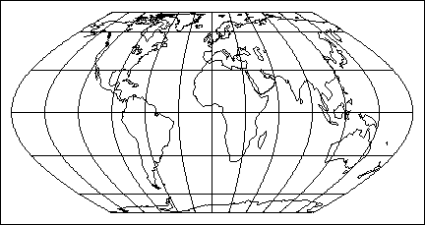

Fig 3.18. The Kravaiskiy VI projection.
Central meridian 0°, 30° graticule.

Distortion
The distortion pattern on Kravaiskiy VI projection is identical to Eckert VI projection. This pseudocylindrical equal-area projection has a relatively low distortion in the Equatorial regions because the Equator is the standard parallel. The pole line avoids a compression of the polar areas close to the central meridian. Continental areas in the higher and lower latitudes are preserved. The equatorial region is not excessively stretched in the N-S direction, which yields to a pleasant map.

Discussion
The Kravaiskiy VI - Wagner I projection is not available in every GIS packages. Nevertheless, it is likely that the user will either find the Wagner, Kravaiskiy or Eckert VI projection and chose among one of them. If none of them is available, the user could choose upon other projection similar by the distortion pattern: e.g. Putnins P4', Werenskiold I and to a less extent Wagner II, the last one being neither conformal nor equal area, but limiting the areal distortion. These projections are very suitable to portray demographic data worldwide.

Conclusion
In general, pseudocylindrical projections are more suitable for general-purpose maps than cylindrical projections. However, the parallels and meridians do not cross at right angle anymore, hence loosing the orthogonality. On the other hand, pseudocylindrical projections show a lower perceptive distortion than on true cylindrical projections, due to the shape of the meridians. However, any time the meridians are curved too much, the continental areas close to the edges are excessively distorted. Pointed polar projections show a severe distortion in higher latitudes. The Mollweide projection is favorable for world-scale mapping purposes, however the Robinson projection is preferred because it prevents the compression in the higher latitudes. Other pole-line projections like Eckert VI and Wagner are suitable, although some polyconic projections can guarantee a lower visual distortion.

Polyconic and pseudoconic projections
The polyconic group is sometimes confounded with the pseudoconic group, the difference being only in the shape of the parallels. On polyconic projections, the parallels and meridians are represented as concurrent curves. On a pseudoconic, the parallels are concentric circular arcs instead. The difference cannot always be observed directly and must be derived quantitatively. From the pseudoconic group, only the Bonne's projection is reviewed.

Distortion generated by polyconic and pseudoconical projections
Polyconic and pseudoconic projections are not especially better in terms of distortion than a pseudocylindrical projection. But the intersection of the parallels and meridians is arranged such that the final projection is usually pleasing to the eye. Pointed polar projections of the groups are, as for pseudocylindrical projections, characterized by an angular distortion in the higher latitude. Compression in the polar areas can occur in order to ensure the equal-area property. Besides, polyconic projections in a circle show an excessive amount of distortion and should be disregarded for general-purpose world maps.

Bonne projection
The Bonne projection (see Figure 3.19.), named after the French geographer Rigobert Bonne in the eighteenth century, is polyconic but sometimes considered as a pseudoconic projection. The pseudoconical concept is to be attributed Ptolemeus who devised a projection with circular parallels and curved meridians, although Bonne was the first one to describe the projection mathematically. His name is almost universally applied to an equal-area projection that becomes the Werner and the sinusoidal projections at its polar and equatorial extremes, respectively.
The meridians are represented by concurrent curves, the parallels by concentric arcs of circles. The center of the projection lies at the intersection of the central meridian with a central parallel of latitude φ0. The parallel is constructed as on a conical projection (Canters and Decleir 1989). Transformation formulas are given below:
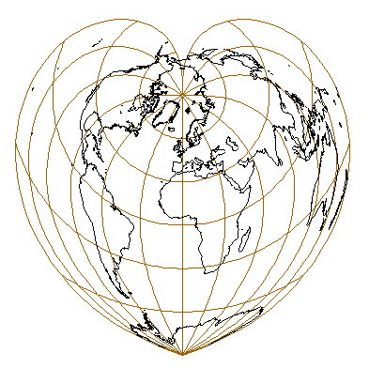

Fig 3.19. The world on the heart-shaped Bonne equal area projection.
Centered on Greenwich°. 30° graticule.

$x=\text{RA}\text{sin}B$ $y=R(\text{cot}ϕ_{0}−A\text{cos}B)$ (62, 63)
$A=\text{cot}ϕ_{0}+(ϕ_{0}−ϕ)$ $B=\frac{(λ−λ_{0})(\text{cos}ϕ)}{A}$ (64, 65)

Distortion:
The parallels are correctly spaced along the central meridian, constructed as arcs of circles of true length, and with the same center as the central parallel. Each parallel is equally divided by curved meridians and is represented in its true length. The choice of the central parallel results in another appearance of the continental areas. Generally, the scale distortion over the continental areas is minimized for a choice of a standard parallel at 50°, but generates excessive distortion in the Southern hemisphere (Australia, South America). However, the scale distortion over the entire surface is minimized for a central parallel at 0°. This is the sinusoidal projection (Sanson). In the other extreme, when the central parallel is at 90°, the pole becomes the center of the projection and the asymmetry between the two hemispheres is severe. On Bonne's projection, no distortion of shape and angles occurs along the central meridian and the central parallel. When moving away from this section, the distortion of angles and shapes increases.

Discussion
During the nineteenth century, the Bonne projection was used for topographical mapping of a few European countries and replaced the Cassini's projection. Today, conformal projections (e.g. conformal conic) are preferred for topographic maps, whereas Bonne, restricted to small-scale maps of continental size, gives the regions both a uniform area scale and the aesthetically pleasing combination of curved meridians and parallels. The use of Bonne is relevant for South America by choosing a central parallel in the middle latitudes of the Southern hemisphere. Most GIS support the Bonne's projection as a continental projection framework.

Aitoff and Hammer-Aitoff's projections
In 1889, the Russian cartographer David Aitoff developed a projection that he derived from the transverse aspect of an equidistant azimuthal projection (Canters and Decleir 1989). The construction principles are not discussed here. On the Aitoff projection, the world is shown in an ellipse with axes in a ratio 2:1. The length of the Equator and the central meridian is correct, but the projection is not equal-area. Three years later, Aitoff's projection inspired Hammer that developed a similar projection preserving the equivalence (see Figure 3.20.). The Hammer projection is commonly referred as Hammer-Aitoff because of its resemblance to the Aitoff's projection. Transformation formulas are as follows:
$x=±2\text{RD}\sqrt{(1−C^{2})}$ $y=\text{RDC}$ (66, 67)
$C=\frac{\text{sin}ϕ}{\text{sin}D}$ $D=\text{arccos}\left\{\text{cos}ϕ\text{cos}[\frac{(λ−λ_{0})}{2}]\right\}$ (68, 69)
in the case that parameter D is equal to zero, x and y will be equal to zero as well. The X-axis lies along the Equator, x increasing eastward; the Y-axis lies along the central meridian, with y increasing northward.
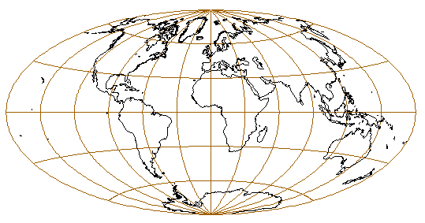

Fig 3.20. The Hammer-Aitoff equal-area projection
centered on Greenwich. 30° graticule.

Distortion
Aitoff is neither conformal nor equal-area, but is a good compromise. The compression near the edges of the map is acceptable. Although the distortion pattern is almost identical, the compression in the polar areas and hence the angular distortion is greater on Hammer-Aitoff projection as a result of the equal-area property. Besides, the central meridian and the Equator on Hammer-Aitoff are no longer at true scale; the scale decreases gradually as the distance from the center increases.

Discussion
The smooth intersection of the meridians with the parallels on Aitoff results in a much more pleasing representation of the world. Nevertheless, compression in the higher latitudes cannot be avoided from the meridional convergence towards the poles (Canters and Decleir 1989).
The Hammer-Aitoff's projection is close in appearance to Mollweide equal-area projection, but the parallels on Hammer are curved rather than straight, which leads to less shearing of the polar regions away from the central meridian (Snyder 1993). The Hammer-Aitoff quickly replaced the original Aitoff projection because of its equal-area property. Owing to the fact that the deformation of areas in the higher latitudes was still high, the McBryde-Thomas projection has gradually replaced the Hammer projection (Wong 1965). The Hammer-Aitoff is generally supported by most GIS-packages; sometimes only the Aitoff projection is available, but this should not make much difference in the final outlook of the map.

Aitoff-Wagner's projection
In 1949, Wagner presented nine new projections, of which two were based on Hammer and one on Aitoff. The E-W compression on the Aitoff projection is rather limited, but can be reduced by the introduction of a pole line. Wagner proposed to improve the transformation formulas in order to obtain a projection whereby the length of the pole line and the curvature of the parallels is comparable with the Winkel Tripel projection (Canters and Decleir 1989). The projection is referred as Wagner IX or Aitoff-Wagner, because it modifies the portion of the Aitoff projection between 70° N and 70° S (see Figure 3.21.). As can be derived from the transformation formulas, this projection is not equal area.
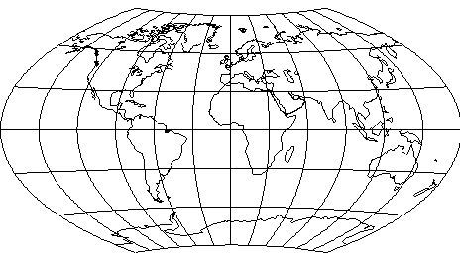

Fig 3.21. The Aitoff-Wagner projection. Central meridian 0°, 30° graticule.

$x=2\text{.}\text{227}{Rδ}^{'}\text{sin}λ^{'}$ $y=−\frac{R}{0\text{.}\text{777}}δ^{'}\text{cos}λ^{'}$ (70, 71)
$δ^{'}=\frac{π}{2}−ϕ^{'}$ $\text{sin}ϕ^{'}=\text{cos}(79ϕ)\text{cos}(5\text{18}λ)$ (72, 73)
$\text{cos}λ^{'}=−\frac{\text{sin}(79ϕ)}{\text{cos}ϕ^{'}}$ $\text{sin}λ^{'}=\frac{\text{sin}(5\text{18}λ)\text{cos}(79ϕ)}{\text{cos}ϕ^{'}}$ (74, 75)

Distortion
The angular and scale distortion is relatively low, while the areal distortion remains significant, but not too excessive. The Aitoff-Wagner projection shows a lower angular distortion than on the original Aitoff, but distorts areas more.

Discussion
Although less area-true than Winkel Tripel, the Aitoff-Wagner projection remains a good compromise between equal-area and conformality properties. This projection is suited to portray general world maps, but Winkel should be preferred when the user can choose either projections.

Hammer-Wagner's projection
Wagner presented a projection in 1941 which was a special case of Hammer's general projection system. Wagner devised a new transformation formula based on Hammer, wherefrom he obtained a graticule with a more favorable distortion pattern that preserves areas. It has curved poles corresponding to the 65° parallels on the Hammer. This projection results in a more familiar representation of the continents than Hammer's graticule and the pseudocylindrical equal-area projections (Canters and Decleir 1989). The parallels are convex to the Equator, which generates smoother angles with the meridians and hence leads to a pleasing representation of the world (see figure 3.22.). Transformation formulas are as follows:
$x=5\text{.}\text{334}R\text{sin}{\frac{δ}{2}}^{'}\text{sin}λ^{'}$ $y=−2\text{.}\text{482}R\text{sin}\frac{δ^{'}}{2}\text{cos}λ^{'}$ (76, 77)
$δ^{'}=\frac{π}{2}−ϕ^{'}$ $\text{sin}ψ=0\text{.}\text{9063}\text{sin}ϕ$ (78, 79)
$\text{sin}λ^{'}=\frac{\text{sin}(λ3)\text{cos}ψ}{\text{cos}ϕ^{'}}$ $\text{sin}ϕ^{'}=\text{cos}(λ3)\text{cos}ψ$ (80, 81)
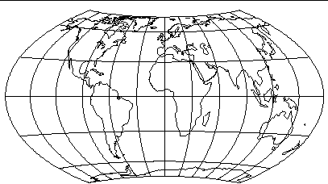

Fig 3.22. The Hammer-Wagner equal-area projection. Central meridian 0°, 30° graticule.

Distortion
Hammer's projection has a severe distortion near the edges of the map, especially in the polar areas close to the central meridians as a consequence of the increasing curvature of the parallels towards the pointed poles. The graticule is such that the preservation of the areas does not lead to a too excessive shearing of the continental shapes. The general distortion parameters are very low for an equal-area projection, which implies that the projection deserves a broader attention in cartographic application that requires the equal area property.

Discussion
The U.S. Environmental Science Services Administration (better known as the Coast and Geodetic Survey) used this projection for climatic world maps, and several commercial mapmakers appear to be using this type for world maps. Unfortunately, most GIS-packages do not support this projection. If it not available, the user should use the Aitoff-Wagner or the Winkel Tripel instead, although these two are not equal-area.

Winkel III (Winkel Tripel)
While Winkel I and II are pseudocylindrical, the Winkel III projection (1928) is a modified azimuthal projection, which is neither conformal nor equal-area, yet belonging to the polyconic group. The central meridian is straight; the meridians are curved, equally spaced along the Equator, concave toward the prime meridian (see Figure 3.23.). Poles are represented as lines 0.4 as long as the Equator. The other parallels are equally spaced along the central meridian and are convex to the Equator (Snyder, Voxland 1989). Like the two other projections, it is an arithmetic mean of two older projections, in this case the mean of an equirectangular projection with two standard parallels and the Aitoff projection of 1889.
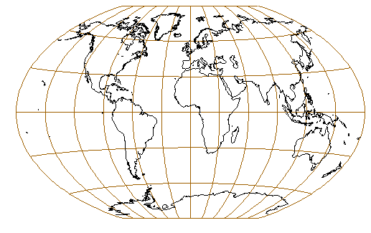

Fig 3.23. The Winkel-Tripel projection, a very good compromise between equivalence and conformality. Central meridian Greenwich. 30° graticule.

Transformation formulas are as follows:
$x=\frac{(x_{\text{aitoff}}+x_{\text{equirec}\text{.}})}{2}$ $y=\frac{(y_{\text{aitoff}}+y_{\text{equirec}\text{.}})}{2}$ (82, 83)
Using the x and y values from Aitoff and the Equirectangular projection being inserted, x and y become:
$x=\frac{R}{2}\left[λ\text{cos}ϕ_{0}+\frac{2\text{arccos}(\text{cos}ϕ_{0}\text{cos}λ/2)\text{sin}λ/2}{\sqrt{{\text{sin}}^{2}λ/2+{\text{tan}}^{2}ϕ}}\right]$ (84)
$y=\frac{R}{2}\left[ϕ+\frac{\text{arccos}(\text{cos}ϕ\text{cos}λ/2)\text{tan}ϕ}{\sqrt{{\text{sin}}^{2}λ/2+{\text{tan}}^{2}ϕ}}\right]$ (85)

Distortion
The general distortion is moderate except near the outer meridians in the higher latitudes. The parallels are very lightly curved, which prevent the unnecessary compression of the polar areas near the central meridian (North-East Canada, Greenland and the Scandinavian countries if the projection is centered on Greenwich).

Discussion
The Winkel III projection is a very satisfying representation of the world. It has a well-balanced distortion pattern, and the areal distortion between the Aitoff-Wagner and the Winkel projection is less on the Winkel. It has received a lot of attention in contemporary atlases and has been used for the mapping of ocean currents, world temperature and prevailing winds (Wong 1965). This projection can be regarded as a very suitable projection for general-purpose world maps.

Lambert conformal projection
In one paper, Lambert (1772) presented seven new projections about a century after the calculus was invented. We retain the Lambert conformal projection of the world in a circle (see Figure 3.24), although other very significant projections have been devised, such as the Lambert conformal conic (of major importance for maps of the USA, but not treated here because it is not suited for world maps), the transverse Mercator and the Lambert azimuthal (or zenithal) equal-area (Snyder 1993). The Lambert conformal projection in a circle has wrongly been attributed to Lagrange, who promoted it later (Canters and Decleir 1989). The meridians and parallels are represented by arcs of circles. In order to ensure conformality, the spacing of the graticule increases from the center towards the edges of the map (same principle on the Mercator applied to the central meridian). The conformality fails at the poles.
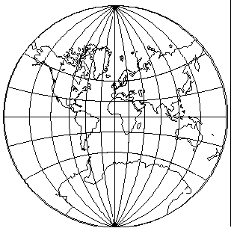

Fig 3.24 The Lambert conformal projection in a circle. Central meridian 0°, 30° graticule.

Transformation formulas are as follow:
$x=\frac{2R\sqrt{1−{\text{tan}}^{2}ϕ/2}\text{sin}λ/2}{1+\sqrt{1−{\text{tan}}^{2}ϕ/2}\text{cos}λ/2}$ (86)
$y=\frac{2R\text{tan}ϕ/2}{1+\sqrt{1−{\text{tan}}^{2}ϕ/2}\text{cos}λ/2}$ (87)

Distortion
To preserve the conformality, an excessive stretching of the polar areas away from the Equator is necessary (as on Mercator). Since the projection is not cylindrical, stretching of the equatorial areas away from the central meridian is a condition as well. This results in an extreme deformation of the continental areas. (Canters and Decleir 1989).

Discussion
The Lambert conformal projection in a circle is rarely used as a world maps (for a conformal projection Mercator is preferred), but rather is used as an outline form as a part of a map projections book or course. GISs support this projection, mainly for data transfer from this projection to a more suitable one.

Van den Grinten projection
In 1904, Van den Grinten devised four new projections for world maps. The first three portray the world within a circle, while the last one encloses the world within two intersecting circles, each representing a hemisphere. In no cases are the projections equal-area or conform; they rather situate themselves as compromises between the two properties. The curvature of the parallels (arcs) differentiates the three first projections.
Van den Grinten criticized Lambert's conformal projection, stating that the areal enlargement from the center of the projection to the outer meridian is too significant.
On the Van den Grinten projection (see Figure 3.25), meridians are equidistantly spaced arcs along the Equator and intersecting at the poles. The spacing between the parallels increases gradually away from the Equator. The 75°latitude is only halfway between the Equator and the poles: therefore the projection is usually limited to 80°N/S and polar regions more than these will not be incorporated.
Van der Grinten, like Lambert, Behrman, Miller, Gall, and Peters was one of the cartographers that tried to counteract the Mercator phenomenon. Van den Grinten's projection is not conformal, but it combines the Mercator appearance with the roundness of Mollweide, a sort of "happy medium" (Wong 1965).
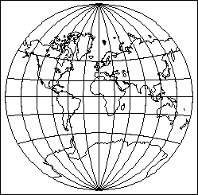

Fig 3.25 The Van der Grinten projection, as a reaction against Mercator.
Central meridian is Greenwich. 30° graticule.
Transformation formulas are given as follows:
$x=±r\frac{A(G−P^{2})+\sqrt{A^{2}(G−P^{2})^{2}−(P^{2}+A^{2})(G^{2}−P^{2})}}{P^{2}+A^{2}}$ (88)
$y=±r\sqrt{1−{\left(\frac{x}{r}\right)}^{2}−2A\left|\frac{x}{r}\right|}$ (89)
where the parameters A, P, G and θ are defined as follows:
$\begin{aligned}A=\frac{1}{2}\left|\frac{π}{λ}−\frac{λ}{π}\right| \\ P=G\left(\frac{2}{\text{sin}θ}−1\right)\end{aligned}$ $\begin{aligned}G=\frac{\text{cos}θ}{\text{sin}θ+\text{cos}θ−1} \\ θ=\text{arcsin}\left|\frac{2ϕ}{π}\right|\end{aligned}$ (89, 90, 100, 101)

Distortion
Like Lambert, Van den Grinten's projection is characterized by a gradual increase of distortion from the Equator to the poles, which is too significant. The continents, except for the polar areas, are tolerably portrayed, but the distortion increases so quickly that this map should be disregarded for a general-purpose world map, except when the aim of the cartographer is to display Equatorial and low- to middle latitudes only.

Discussion
Van den Grinten was used quite a lot for wall maps throughout the twentieth century partly because the general resemblance to Mercator with somewhat reduced area distortion. When first proposed, the Van den Grinten promptly provoked favorable comments from France, England, and U.S. Van den Grinten was the base map at the National Geographic Society from 1922 to 1987, although later it was replaced by the Robinson's projection. Van den Grinten is one of a number of compromises that curried favor; it reduced the extreme size exaggeration found on the Mercator and avoided the extreme shape distortion that marks the equivalent projections (McLeary 1989). Van der Grinten was also adopted by the U.S. department of Agriculture in 1949 as the base map for economic data. Between 1940 and 1960, the Van der Grinten became the second most heavily used projection for world maps, after the interrupted Goode homolosine (not discussed here). In Russia, the projection has been used for numerous political and mineral mapping purposes. For many years, the high level of usage of the Van der Grinten projection was an extension of the acceptability to the public, even the geography community, of the gross area distortion of the Mercator (Snyder 1993). GIS packages usually support the translation to and from a Van der Grinten projection, although sometimes it is only available for map projection transfer.

Conclusion
Pseudoconic and polyconic projections diverge from pseudocylindrical projections in the shape of the parallels. They are straight lines on pseudocylindrical projections but curved on every projection considered in this section. The curvature of the parallels and meridians forms a graticule that is very pleasing from a perceptual point of view.
Bonne, the only pseudoconic projection discussed in this paper should be disregarded for world map purposes since it excessively stretches continental areas close to the edge of the map. However, it remains very suitable for continental scale mapping. Pointed-polar polyconic projections reflect the roundness of the Earth, but at the same time generate a significant angular distortion in polar areas close to the central meridian that increases when the equal-area property is needed. On the other hand, pole-line polyconic projections prevent this angular distortion yet stretch the polar areas in an E-W direction. This stretching is more pronounced on equal-area projections. The Van der Grinten and the Lambert projection of the world in a circle should be disregarded for general-purpose maps. Even if the visual distortion is more acceptable than on a Mercator, it is still excessive. From a perceptive point of view, polyconic projections are preferred over pseudocylindrical projections because the angle at the intersection of meridians and parallels is softer.

Minimum-error projections
Minimum-error would suggest to the reader a projection characterized by a minimum amount of distortion. The term can also be applied to an existing projection that, under a given a set of constraints, would be derived by applying the least-square principle. Usually, the transformation formula is modified by the introduction of additional parameters that will best meet the new criteria. Most work on minimum-distortion projections was developed between 1850 and 1950 after the development of the least-square techniques. Unfortunately the unavailability of super computers left the transformation flexibility of existing projection rather weak (Snyder 1995). However, today's computers give the possibility to calculate very complex formulas in a short time frame. There have been several attempts since 1980 to develop minimum-error world maps which are neither conformal nor equal-area by Peters' son Aribert in Germany, Canters in Belgium and Laskowski in the U.S.A.

Distortion generated by minimum-error projections
A reasonable criterion to measure distortion is a modification of Airy's least-square expression. The logarithmic expression assures that enlargements and compressions have an equal weight in the equation given here:
$\iint_{s}{[(\text{ln}a)^{2}+(\text{ln}b)^{2}]_{{}^{}}}\text{dS}$ (102)
where a and b are the Tissot's major and minor axes respectively. S is a selected surface on the final map and a and b are integrated over the entire surface S. The three projections that are discussed in this section have in common that they all use one finite measure of distortion: distances between two locations on the globe are compared with the same distances on the map and then averaged for all distances involved in the calculation.
The projections are developed through an iterative process that minimizes the total average distance distortion. The approach for a minimum-error projection consists of developing two n-ordered polynomial equations defining the transformation between the spherical coordinates on the Earth and the Cartesian map coordinates, as shown in the equations 103 and 104.
$f(λ,φ)=\sum_{i=0}^{n}{\sum_{j=0}^{n−i}{C_{\text{ij}}λ^{i}φ^{j}}}$ $g(λ,φ)=\sum_{i=0}^{n}{\sum_{j=0}^{n−i}{C_{\text{ij}}^{'}λ^{i}φ^{j}}}$ (103, 104)
where λ and$φ$ the geographical longitude and latitude and f and g two n-order polynomials. The values of the polynomial coefficients Cij and C'ij define the characteristics of the projection. The number of coefficients increases with an increasing polynomial order n (De Genst, Canters 1995). As the number of parameters involved increases, so does the complexity of the formulas but the mean linear distortion value decreases (Canters 1989). Map projection features can be introduced into the transformation model by putting constraints on the value of some of the coefficients. This will reduce of course, the number of modifiable coefficients and thus restricts the flexibility of the transformation. Keeping all coefficients introduces high visual disturbance. So, in order to display graticules that meet pre-defined criteria such as 2:1 ratio of the axes or straight parallel lines of latitude, some constraints must be imposed. This general equation gives the flexibility to create tailor-made projections that satisfy a particular design goal (De Genst, Canters 1995).

The three projections vary among themselves by additional constraints that change the final outline of the projection. For instance, Aribert Peters' projection is very close to the Hammer-Wagner projection. The Canters' projection has additional constraints and refines Peters' technique. The general outlook is improved. Laskowski is the only minimum-error projection that combines both finite and infinitesimal distortion theories.
Generally, these projections are very appropriate for general-purpose maps of the world. Unfortunately, most GIS packages do not support them.

Aribert Peters' projection
Aribert B. Peters is not to be confused with Arno Peters who re-introduced the Gall equal-area cylindrical projection. In 1984, A. B. Peters developed a world map with minimal distortion of both angles and distances. It is an equal-area projection with small distance distortion, sometimes called the distance-related world map and exhibits lower angular distortion than any other equal-area map (see Figure 3.26.). According to Peters, an equal-area maps that minimize distance distortion also minimizes angular distortion. Peters disregarded Tissot local theory of distortion, because it includes infinitesimal areas while his projection concentrates on measurements and calculations based on finite distances taken from both globes and map (Peters 1984). The aim of the distance-related world map is to keep overall distortion to a minimum. Transformation formulas are given below:
$x=P_{3}\sqrt{2}\text{sin}(P_{2}λ)\frac{e}{\text{de}}$ $y=P_{1}\sqrt{2}\frac{b}{\text{de}}$ (105, 106)
The different parameters are defined as follows:
$a=\text{sin}(0\text{.}\text{33}λ)$ $b=\text{sin}ϕ$ $c=\sqrt{1−0\text{.}\text{821}}b^{2}$ (107, 108, 109)
$d=0\text{.}\text{546}$ $e=\sqrt{(1+\text{cos}(0\text{.}\text{33}λ))c}$ (110, 111)
x and y are the general Cartesian coordinates depending on three general parameters that, combined together, reduce the overall distances distortion. The other variables a, b, c, d and e have been introduced to simplify the final transformation formula while reducing its length.
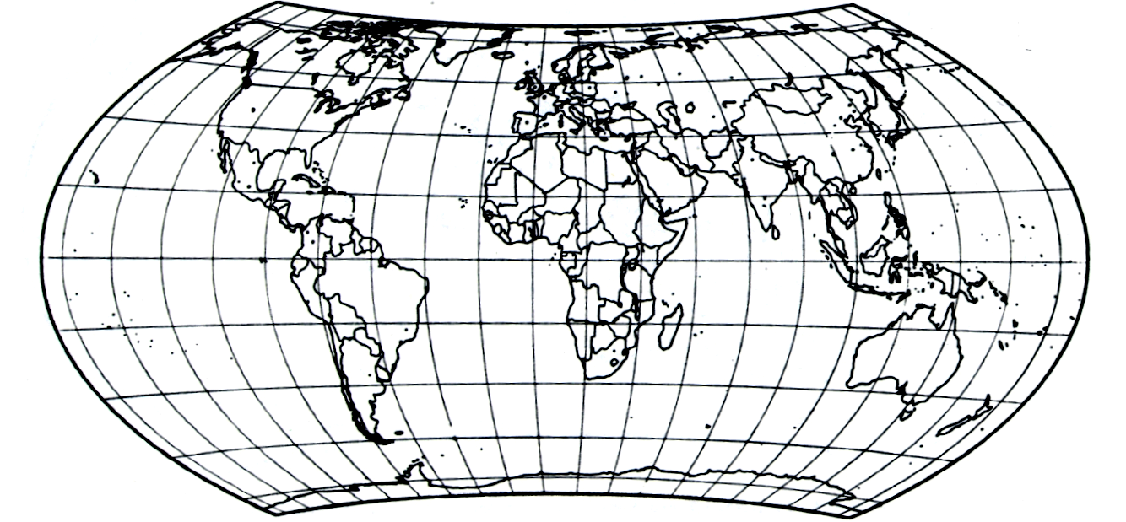

Fig 3.26. The Aribert Peters projection, a projection that minimizes distance distortion.
Central meridian 0°. 20° graticule (after Peters 1984)

Distortion
Peters introduced a distortion index v based on the distortion value f defined below:
$f=\frac{1}{n}\frac{\left|r_{\text{ij}}−R_{\text{ij}}\right|}{\left|r_{\text{ij}}+R_{\text{ij}}\right|}$ (112)
$v=a\int{\int{\int{\int{\int{f}}}}}\text{cos}(ϕ)\text{cos}(ϕ^{'}){dλdλ}^{'}{dϕdϕ}^{'}$ (113)
where Rij is the geodesic distance between two points on the globe and rij the distances between the same points on the map. A total of 60,000 points were computed in the formula. The second formula gives the value of v, which is the overall mapped distortion in the value of the integral. The geographic coordinates φ, λ are integrated and then multiplied by a, which is a normalizing constant. The final projection minimizes v.
The map has less distance distortion than on any other world maps and a lower overall angular distortion than other equal-area maps. According to Peters, further reduction of angular distortion is possible with sacrifice of the equal-area property. The true sizes of most continents are more closely approached on a distance-related map than on other maps. The realistic shape of the continents is preserved.

Discussion
Peters postulated that if distance distortion includes angular and areal distortion, on equal-area maps angular distortion increases as distances distortion increases. The minimum-error distortion approach yields not only optimum quality world maps, but also optimum quality maps of any size. The Peters projection is not supported by any GIS, although the GIS user with computational expertise could integrate it within the software. On the other hand, the transformation formulas are considerably complex resulting in a time-consuming integration procedure.

Canters' projection
The Canters projection (see Figure 3.27.), also called the minimum error map pseudocylindrical projection with equally spaced parallels and pole line, is somewhat less known. The starting point can be compared with the Robinson projection: given a set of prerequisite constraints (curved meridians and parallels, a ½ Equator/pole ratio), the mapmaker tries to find the best possible representation of the Earth. But here, Canters minimizes the distortion by measuring 5000 distances on the generating globe and conserving them as accurately as possible when reporting them on his map. Canters' approach is very close to Aribert Peters' technique, although Canters criticizes the choice of the 30,000 random distances (60,000 points). Geodesic distances greater than 30° may generate an erroneous mean linear distortion value, resulting from the compensation of subsequent enlargements and reductions that occur along a line between two considered points. Canters adds that the method used by Peters is objective from a distortion point of view, but lacks a perceptive evaluation. The Robinson approach for instance starts from a set of given geometric and special constraints and eventually devises a projection through an iterative process that fulfills these constraints. Canters' map is neither equal-area, conformal nor equidistant, but looks very right (Canters 1989). Transformation formulas are given below.
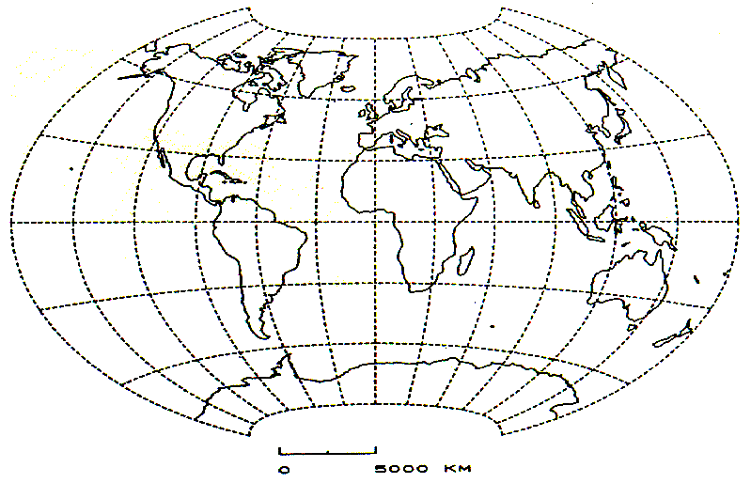

Fig 3.27. The Canters projection minimizes distance distortions all over the map.
Centered on Greenwich, 30° graticule (after Canters 1989)

$x=R(0\text{.}\text{9305}λ−0\text{.}\text{1968}{\text{λϕ}}^{2}−0\text{.}\text{0067}λ^{3}ϕ^{2}+0\text{.}\text{0076}{\text{λϕ}}^{4})$ (114)
$y=R(0\text{.}\text{9305}ϕ+0\text{.}\text{0394}λ^{2}ϕ+0\text{.}\text{0005}λ^{4}ϕ−0\text{.}\text{0115}λ^{2}ϕ^{3})$ (115)

Distortion
Canters started from a high level of complexity and gradually reduced the number of parameters through the introduction of new constraints, such as the 2:1 ratio of the axes, a pole line half the length of the Equator, the symmetry about the central meridian and the Equator. A visual comparison with the Winkel-Tripel projection shows that the distortion patterns are very close and consequently very low (Canters 1989). The projection is developed in such a way that the map-reader should perceive the roundness of the Earth.

Discussion
This map tries to give a portrayal of the world in a way as realistic as possible. It has been adopted as a reference map intended for use in the first three years of secondary education in Belgium (Canters, Declercq 1991). This map would be very suitable as a general-purpose map, but regrettably no GIS packages support this projection. It is left to the user to integrate this projection into the software, a rather time-consuming procedure.

Laskowski's projection
In 1991 Laskowski presented a new minimum-error map projection based on two different methods that minimize the overall distortion on a map (see Figure 3.28). The most dominant map error measure is certainly Tissot's ellipse of distortion ("Indicatrice de Tissot"), which is an infinitesimal measure of distortion. Although Tissot is valuable for small areas, the finite measure of distortion is more suitable for larger areas and should be integrated when designing minimum error world maps. In this framework, Laskowski introduced a new distortion measure, which is a combination of Tissot's indicatrices with the mean square measure of errors in finite distances, distributed over the surface of the Earth. The so called 'mixed-error measure E' is expressed as a fifth degree polynomial in geographic coordinates (φ, λ) and meets some design constraints such as the symmetry about the Equator and the central meridian (Laskowski 1991). Transformation formulas are given below:
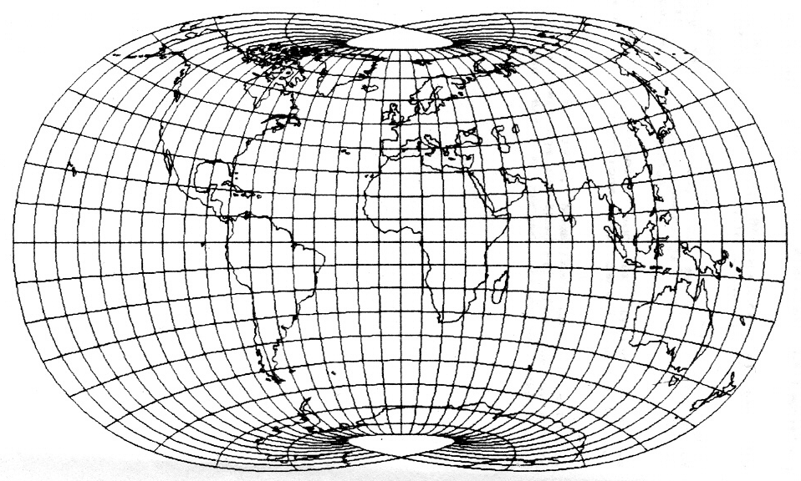

Fig 3.28. The tri-optimal projection. Centered on Greenwich, 10°graticule. (after Laskowski 1991)

$x=0\text{.}\text{975534}λ−0\text{.}\text{119161}{\text{λϕ}}^{2}−0\text{.}\text{0143059}λ^{3}ϕ^{2}−0\text{.}\text{0547009}{\text{λϕ}}^{4}$ (116)
$\begin{aligned}y=1\text{.}\text{00384}ϕ+0\text{.}\text{080294}λ^{2}ϕ+0\text{.}\text{0998909}ϕ^{3}+ \\ 0\text{.}\text{00199025}λ^{4}ϕ−0\text{.}\text{0285500}λ^{2}ϕ^{3}−0\text{.}\text{0491032}ϕ^{5}\end{aligned}$ (117)

Distortion
The projection minimizes the deviation of Tissot's error ellipses from a unit circle, while preserving the geodesic distances between distinct points on the globe as much as possible. The combined map distortion measure (E) was expressed as the sum of a local and a global variable (L, G).
$E=L+G$ $L=\frac{1}{n}\sum_{i=1}^{n}{(\frac{a_{i}}{b_{i}}−1)^{2}+(a_{i}b_{i}−1)^{2}}$ $G=\frac{[\frac{1}{m}(D_{\text{ij}}−d_{\text{ij}})^{2}]}{\sqrt{\frac{1}{m}D_{\text{ij}}^{2}\text{.}\frac{1}{m}d_{\text{ij}}^{2}}}$ (118, 199, 120)
E is the combined distortion measure with a local infinitesimal measure L and a global finite measure G; a and b are the axes of the Tissot's indicatrice, a being the major one and b the minor axis respectively. D is the geodesic distance between two selected points (i, j) on the globe and d denotes the corresponding map distance between the projected endpoints of D. 5,000 distances (m) were uniformly distributed over the globe. The difference D-d gives an idea of the distance distortion (this measure was already introduced by Gilbert in 1974. The resulting outline is very pleasant to the eye and even if the technique used by Laskowski is rather quantitative and not perceptual, the resulting map is characterized by a low distortion value. The polar areas are not excessively deformed, and neither is the equatorial area. Noticeably, the poles are represented by small "triangles" which is a good compromise between a pointed polar projection and a projection where the pole is depicted as a line. It gives the map reader the visual impression that Antarctica is round and not stretched as it is too often on most pseudocylindrical areas.

Discussion
The tri-optimal world projection is a compromise among equivalence, equidistance and conformality. In no case does the projection preserve one of the listed properties, but since the overall distortion pattern is low, this map is very suitable for general-purpose maps. Unfortunately, most GIS-packages do not support this minimum-error projection, probably because of its complex transformation formulas.

Conclusion
Minimum-error projections have the benefit that they do not generate a lasting distorted effect on people's general perception of the world. Generally, they are constructed in such a way that they evoke the fundamental roundness of the Earth, especially Canter's projection. However, only on Laskowski's tri-optimal projection are the polar areas close to their original shape. At these latitudes, the meridians are very close to each other, and accordingly the map portrays their convergence. These projections remain mostly academic, lacking commercial applications, which is a serious drawback. Other pitfalls of these projections include the rather complex formulas and hence they are not developable without a computer. As Snyder (1994) points out, minimum-error map projections seems more justifiable for smaller areas, even if the results generated by a minimization of error are almost not perceivable by the map reader. This is useful when the map goal is to preserve distances and measurement first, then area and shape.

In this framework, the use of traditional and very often mathematically complicated projection systems for world maps is more or less superfluous. For a given set of constraints map transformations can be obtained that give a more realistic portrayal of the continental area than existing world map projections with a similar configuration of the graticule. If a more traditional projections system is explicitly required, a least-square approach can be applied to convert these to the polynomial format and at the same time reduce their overall distortion. The GIS user should strive to acquire the necessary knowledge in terms of computer expertise and be able to integrate these projections.

Map projection issues for GIS applications
One of the most challenging aspects of map projections is the selection process. The user has to choose among an abundant variety of projections, determined by the software in use. With the analysis in the previous sections, can the GIS user become more familiar with the properties of every projection (See Appendix B for an entire list of major map projection properties). It turns out that most cylindrical projection should be disregarded and replaced by more appropriate projections, except when straight meridians are required. Generally, pseudocylindrical and polyconic projections are preferred, but their properties might make them inefficient to optimize the final purpose of the map. The use of minimum-error map projections is advised for general-purpose mapping. These projections are very acceptable from a quantitative and perceptive point of view. It is now the task of the mapmaker to decide which projection to select in order to better serve his or her needs. Too often, a projection is rapidly chosen because it is the first-at-hand. To assist the GIS user, several schemes are evaluated, some more valuable than others, some more quantitative than qualitative. As Robinson (1951) pointed out, a quantitative analysis of the deformation on a projection would help to retard the tendency towards the selection of a too conventional map projection.
Before introducing the subject of map projection selection, it is important to evoke data transfer among different coordinate systems. The transfer of geographical data from one projection framework to a more suitable one is discussed.

Data transfer in GIS among supported projections
Among the map projection issues for GIS applications, the combination of geospatial data sets from one projection framework with those from another can hamper the visual display of the geographic features. Generally, this problem occurs when large-scale features recorded in different projection are displayed together. This problem is now resolvable in most desktop GIS through a projection translator (e.g. Arc View projection utility).
Generally, the user has geographic data, i.e. in longitude λ and in latitude φ. Within a GIS, this data is commonly displayed on a Platte Carrée projection. However, the user can plot data in another projection that is more suitable for the final purpose of his map. The mathematical process is as follow:
$(x_{a},y_{a})→(ϕ,λ)→(x_{b},y_{b})$ (121)
<inverse solution><forward solution>
where xa and ya are the Cartesian coordinates of the original projection, xb and yb the coordinates of the final projection. The conversion from geographical coordinates into Cartesian coordinates is the normal process and is regarded as the forward solution. The inverse solution is the preliminary conversion required to find the geographical coordinates from the original Cartesian coordinates xa and ya (Maling 1991). Note that the original coordinates may have been digitized, and then are converted in a final common projection framework. If the data is recorded in geographic coordinates λ and φ, the inverse solution is not needed. In the past, such projection translators were not available, and data had to be transferred by hand. Other stages in the transformation process (eqn [121]) have been devised to support a change of aspect as well.
The user should be aware that the ellipsoid system may have been used to record his or her data. Data sets displayed in the same projections but measured on two different geodetic systems will not be displayed properly. Fortunately, current GISs support conversion among different geodetic reference systems.

Map projection selection schemes for GIS applications
Since the problem of converting coordinate systems into a final projection framework can be easily be solved, the user should focus on the choice of a suitable projection to enhance the message of his map, or better said, the purpose of the map should guide the user to a projection selection (Gilmartin 1985). The importance of spatial data integration through the use of map projections has been discussed in the literature (Goodchild 1991). Geospatial data is often collected in different projections, but the user may not be aware of it. Overlaying and compiling this information toward a single and unique projection reference depends strongly on the purpose of the final GIS/mapping application (Canters 1995). The issue arises when the user is faced with the choice of a suitable projection in order to portray his data with the minimum amount of distortion while preserving specific geometric and/or general features earlier discussed.
Gauthier (1991) and Gilmartin (1985) have already examined the selection of an appropriate projection framework for the display of geographic information on journalistic maps. The message the map is supposed to communicate is hampered when the final selection is not suitable.
While different map projection selection concepts have already been discussed, the issue of what they should include and how they should be implemented still leaves us with many uncertainties. Iliffe (2000) discusses what is meant by a suitable projection. A suggested order of criteria is given here below:
- The projection should preserve any properties that the use of the map dictates.
- A suitable projection is one that minimizes the scale factor over the region, i.e. that the scale factor should be as close to unity as possible everywhere.
- Any additional geometric properties would usually be considered after the scale factor.
Maling (1973) discussed some concepts for the selection of map projections, mainly based on geometric features and map purpose(s). Snyder (1987) proposed two different approaches to the selection process, a more parametric approach and an expert system. Nyerges and Jankowski (1989) presented their Map Projection Knowledge Base System (MaPKBS), unfortunately more conceptual than practical. Further relevant authors are Kessler, whose master's thesis was concentrated on the development of a map projection selection system. The most recent contributors are De Genst and Canters (1995).

In the following section, several systems dealing with map projection selection from a parametric approach are presented and briefly analyzed. Thereafter, expert systems are evaluated. The following is a discussion on the properties and implementation issues that selection systems should include.

Approaches to map projection selection
Two strategies are available for a cartographer confronted with the selection of a map projection for geographical purposes: either the mapmaker analyzes the application, specifying the features that the map projection must have and eventually creates a projection that best meets these specifications, or the cartographer selects an existing map projection that comes closest to the specified criteria. The first procedure was followed by Robinson (1974) when developing a new map projection for the Rand Mc Nally Company. But this method is very time consuming and requires a great deal of expertise on the part of the cartographer. The latest is simpler and has dominated the cartographic world for decades, but does not always lead to an ideal solution. A few considerations by notable authors on the map projection selection process are given here :

Snyder
Snyder (1987) considers the selection of a projection to be a process of describing the following characteristics of the application:
- The size of the area to be displayed -directly linked with the scale- (global, hemisphere, or smaller)
- The required properties (i.e. conformality, equal-area, equidistant, azimuths preserved, great circles as straight lines, etc…)
- The general extent of the region (along a great circle, along a small circle, radial)
- The general location of the region (Equatorial, mid latitude or polar)
The need for special properties should be considered for maps of areas larger or equal to a hemisphere; these are the preservation of angles, areas, distances, straight loxodrome or minimal distortion. When the mapmaker deals with smaller areas, the selection is primarily based on the extent of the region unless a special property is required that limits the choice to just one projection (Kessler 1992).

Maling
Maling (1992) defined three rules that should be taken into consideration when determining the projection class:

- Azimuthal projection must be used for maps of the polar regions.
- Conical projections are to be preferred for areas of middle latitudes
- Equatorial regions are best mapped using cylindrical projections.

If transverse and oblique aspects are also to be taken into consideration (they might greatly reduce the distortion when applied correctly), these rules can be put aside and the projection class is a function of the shape defined by the region, regardless of its geographical location.
Maling adds that the purpose of the map specifies the properties that the map projection must have and therefore limits the set of candidate projections. Once the geometric characteristics of the map (e.g outline, etc…) and the purpose have been applied, Maling suggests that extreme distortion values within the area of interest be compared in order to decide which of the remaining map projection is to be preferred.

Mekenkamp
Mekenkamp (1990) published what was probably the first to attempt to make the selection process more straightforward by restricting the number of available projections to a set of 11 projections from the general conic group. Map projection selection should, according to him, answer two fundamental questions:
- What is the extent of the area being mapped? and
- What is the purpose of the map?
Starting from this point he then distinguishes three types of regions that refine the map projection selection:
- “one-point region”, extending equally in all directions
- “two-point region”, extending along a great circle
- “three-point region”, characterizing a triangular region
The type of region determines the class of projection. Identifying the goal as a one-point, a two-point or a three-point region leads to the choice of an azimuthal, cylindrical or conical projection, respectively (Mekenkamp. 1990). The azimuthal projection is very useful to represent circular areas and principally pole areas. The cylindrical projection is used to portray landmasses that are extended in an East-West direction -for a country that extent North-South, one will opt for a transverse aspect of the projection (e.g. Chile).

Purnawan (parametric approach)
Bebas Purnawan (1991) developed a map projection selection method based on a parametric approach. It deals with the selection and optimization of conformal projection for small-scale maps. Conformal projections are usually used for large-scale mapping (e.g. topographic maps) where the preservation of angles is the main requirement of the map. Conformal projections should not be selected for world maps, unless this property is required by the purpose of the map.
Purnanwan designs a selection scheme that utilizes lines of constant distortions. By applying an analysis of deformation to a projection, values can be plotted on the map that describes how much linear, angular or areal distortion is exhibited by that particular projection at a given point (Kessler 1992). The method developed by Purnawan consists of optimizing parameters in a generalized transformation equation. This equation uses coefficients that may be considered as variables. By varying these variables, one can generate various projections with less or more distortion. The final projection should have the minimal distortion over the mapped area. This method optimizes the region to be mapped and is very suitable for continental and larger scale mapping. On the other hand, the mapmaker needs some expertise in computational mathematics to implement this technique.

De Genst-Canters (parametric approach)
William De Genst and Frank Canters proposed in the mid-1990s a new map projection selection scheme where the projection should be acceptable from a perceptive point of view but which, at the same time, results from the minimization of an objective distortion criterion. This approach is partly based on the work of Canters (1989), discussed earlier. The cartographer can optimize existing transformation parameters or can develop a new map projection formula. The formula, rather complex, has the advantage of meeting the pre-defined constraints of the map purpose. The n-order polynomial transformation formula in eqns [103, 104] is gradually reduced with an increasing amount of geometric properties. The final projection is acceptable from both a qualitative and a quantitative viewpoint.

Expert systems for map projection selection
The advantage of an expert system over a parametric approach is that it allows the GIS novice to arrive at logical answers to a particular question. An expert system is built around existing projections contained within the knowledge-based system (e.g. a GIS). This knowledge base is defined as an organized hierarchy of information that, when accessed at a specific level, allows the expert system to use logical inferences to generate the next query and so anticipate possible response (Kessler 1992). Usually, the expert system prompts for the necessary information matching desired properties. Once the user specifies the characteristics that the map should have, the system selects and displays the appropriate projection. The expert system approach has the advantage over the parametric approach in that projections already exist. But usually, expert systems are not capable of generating projections (shortcoming discussed and solved by De Genst and Canters). The aim of an expert system is to match the projection to the needs of the user. An important issue is combining the usefulness of an automated projection-generating package with the knowledge of how to maximize its potential.
Three systems are reviewed here; each approaches the question of selection differently; each has a unique knowledge-based system, and has different user interfaces.

MaPKBS
Map Projection Knowledge Base System (later MaPKBS) was developed by Nyerges and Jankowski in 1989. It prompts the user to respond to a hierarchy of queries that progressively ask more detailed questions about the required projection properties and characteristics. These queries include the area to be mapped, its location and extent, and also geometric attributes (shape, size, etc.).
The first query the user always sees is to specify the extent of the geographic area to be mapped. The query structure inside the system is built around the idea of a tree level category-object-attribute sequence (Kessler 1992). It is an interesting way to present the sometimes inconsistent and confusing requirements of the selection process. The following queries include considerations concerning the special properties that the projection should preserve, the function of the map, the geometric properties, and the type of display. The map scale is the last step in this tree structure
The authors recognize that their systems are not perfect: for instance, there is no way for the user to specify the map’s purpose in the query structure (already pointed by Hsu as the first step when selecting a map projection). Specifying the function of the map would apparently help users in supplying responses to the other queries.

EMPSS
The system developed by Snyder is called the Expert Map Projection Selection System. Compared to the previously proposed system, it assumes that the user is more likely to be aware of the function of a map than to know the specific projection properties desired. Therefore, this system would be good for those who need to make a match between a projection and a map goal. Snyder’s system (1989) has two approaches: the first is a sort of question and response session while the second level is the evaluation session in which the projections are analyzed. The question and answer session is divided into three different categories: the size of the region to be mapped (interruption, direction and extent), the scale of the map, and general functions.

The knowledge base system has about 50 projections, each of them having a value (0 to 1) assigned to it. The value is then assigned based on how well the projection satisfies each query. For each and every step, a value is added. Eventually, projections with a zero-value will be disregarded while projections with the highest value probably suit the user’s needs well (Snyder 1987).

This approach is very effective for the user who is not fully aware of map projection properties. However, Kessler (1992) discusses the disadvantages of Snyder’s approach. The ordering of the queries is fixed, which does not allow for a particular projection property to be emphasized. Also, some projection requirements may conflict during the selection process. The selection scheme should emphasize more on a rank/ordering or a method to place more weights on some projections properties/characteristics than on others. When an expert system does not allow ranking, the user must rely on the system’s ordering of the queries, which may not select an appropriate projection.

MaPSS
Kessler (1991) develop a Map Projection Selection System, built around two very important concepts: the ability to give a higher precedence to certain projection properties and characteristics, and the inclusion of design considerations in the selection scheme. The user is asked to weight broad categories, namely the geographic accuracy and the design issue. The geographic accuracy is concerned with the function of the map, the area to be mapped and the shape of the region (Kessler 1992). Thereafter, the user chooses the desired projections properties that will best match his or her desired map purpose. The design issues are original, because they enable the cartographer to emphasize a particular message.
When the user enters MaPPS, he or she is asked to weight each of the broad categories. As a result, the user can chose a projection with respect to preserving geographic accuracy, create a projection with an emphasis on design issues, or a combination of both that would lead to a compromise solution (Kessler 1991). Eventually, the projections are analyzed, based on what the user has requested. The values become numerical indices, which describe how well each projection satisfies a particular query. Finally, as with EMPSS, projections are listed with their values and compared to provide a general suitability index ranging from good to bad.

Discussion
We have analyzed different map projection selection systems characterized by a parametric approach on the one hand and expert systems on the other. The major tradeoff from the first group is that they do not have projections available for selection: it is up to the user to set the parameters in order to get the best result for the final map. Expert systems propose a series of projections, but the number of available projections for world maps is sometimes rather limited, and expert systems do not offer the possibility to generate projections, whereas the parametric does. A system that would combine both expert and parametric approach would probably give the user more freedom when choosing a reference map. Kessler (1992) listed five components that such a “hybrid” system should support:
- A method for the user to specify the projection requirements
- An expert knowledge base that would assist the user in making decisions about the map projection match.
- A method to translate the textual requirements into mathematical parameters for the transformation equations
- A projection generating system that would take the parameters for the transformation equations
- A component to take the parameters and generate the map projection.

In this framework, it is interesting to repeat the importance of geometric and special properties. These have been defined and detailed in chapter one and should be at the origin of any map projection selection system. The user can make a quick list and check which properties are required for his final map. Then, starting from a defined subset of available map projections in the selection system, one can see whether the user's needs can be fulfilled within the system. It is important to include a generous number of projections within the system in order to maximize the output possibilities.
Once there is a small set of resulting map projections, one can select the one with the least overall distortion. Since every map projection has a transformation formula (see eqn [1] and [2]) characterized by a specific amount of parameters, it should be possible to optimize these to reduce the distortion. When the optimization of parameters does not yield satisfying results in term of visual appearance, the transformation formulas can be further optimized, as defined in the equation here below (De Genst, Canters 1996):
$X=\sum_{i=0}^{n}{\sum_{j=0}^{n−i}{C_{\text{ij}}x^{i}y^{j}}}$ (122)
$Y=\sum_{i=0}^{n}{\sum_{j=0}^{n−i}{C_{\text{ij}}^{'}x^{i}y^{j}}}$ (123)
Distortion is reduced again by optimizing the value of the polynomial coefficients $C_{\text{ij}}$ and $C_{\text{ij}}^{'}$.

Implementation Issues
This procedure (see Figure 4.1) is close to an optimization process in order to reduce the distortion to a level where it becomes visually and quantitatively acceptable. The optimal solution is reached by minimizing a distortion criterion within a number of applications-specific constraints (Canters 1995). The use of a finite distortion criterion as well as the ability to perform error-reducing transformations, which allow to improve upon the results obtained with standard map projections, ensure the general applicability of the selection procedure.

Functional constraints
Polynomial transformation
Parametric
Optimization
Recommended
Projection Type
Selected map projection with complete
definition of projection parameters

Figure 4.1. A proposed procedure for the selection of map projections (after Canters, 1995)

Considerations for an objective approach
In this study, the extent of the area to be mapped has not been taken into consideration, since this study is limited to world-scale mapping. This greatly facilitates the user in his choice of an appropriate projection framework. The purpose of the map defines whether any special properties are required. A map showing statistical data requires an equivalent projection, whereas conformal projections are preferred if accurate angles of flows are greatly needed. Geometric properties, often narrow the number of candidate projections. These properties have a visual influence on the look of the map and consequently a lasting/pleasing effect to the eye. It should be noted that even if an equivalent projection is required, a compromise or minimum-error projection could sometimes better portray the continental shapes while preserving the message of the map.
The projections can also be evaluated in terms of suitability to specific constraints (generally special and geometric properties) and consequently be weighted. A final output would rank the different projections. Afterward, the projection should be centered on the area of interest, and a specific aspect should be selected if possible. However, one of the major drawbacks in today's desktop-GIS is the rather limited number of supported projections. Some systems only allow the user to chose among five to seven projections and this highly restricts the freedom of the user. Whenever the user is somewhat more comfortable with command-based GIS, a more suitable projection can be chosen. Users with solid expertise in computer programming can envisage an optimization of the graticule of the selected projection that would guarantee a minimum visual distortion.

Towards a more interactive solution?
As we struggle with the problem of flattening the Earth, along with the advances of new technologies -such as computer graphics- we may no longer need many of the old standard projections for many applications. Distortion could be reduced to zero by using a rotating globe on computer or television screens (backdrop) to portray the Earth. There is a possibility, on a computer screen to view the Earth from any position as if it were a sphere (azimuthal orthographic projection, where the viewpoint is put at the infinite…), and then to enlarge any given area of interest on a television monitor (Brinker 1990). This method associates two types of projection: an orthographic projection for the whole globe and a tangent plane (generally an azimuthal projection) for local areas. The technique is rather simple.
Usually the starting point is an orthographic (point of vision is infinite) projection of the globe. The beautiful characteristic of this projection is that in spite of showing only half of the world at one time and having great distortion near the perimeter, it looks like the world. The Earth is first centered to a well-known reference point such as the meridian of Greenwich. Then the globe is rotated around its polar axis and tilted at the same time to bring the “target area” into the center of the screen. Next, either a rapid or a gradual transition is made as the target area is enlarged. The result could be a map of a country, state or city, any of which can be adequately shown by using a tangent plane of a map at a suitable scale.

An example is shown below for Australia: First, the projection is centered on the desired country (see Figure 7.2.), and later one can zoom in (see Figure 7.3. and 7.4.). The idea Brinker proposes is interesting for interactive presentation but impractical since not everyone has access to a computer room or to “map rooms” consisting of TV monitors and computer screens.
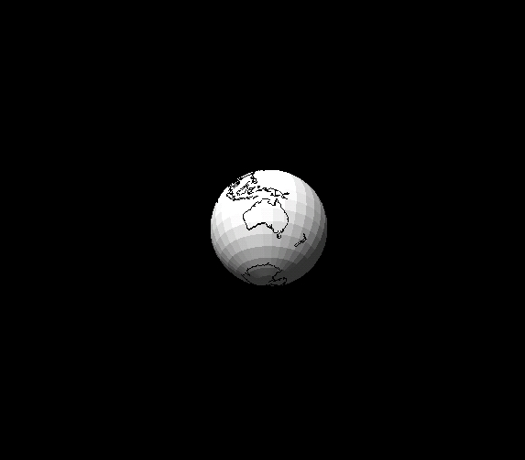

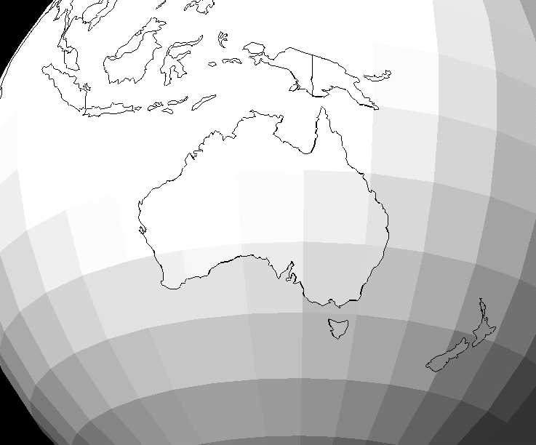

Figure 4.2. and 4.3. From left to right: The world as it is perceived from the space. It is actually an orthographic projection. Following a closer look at a particular continent or country, here Nouthern Autralia.

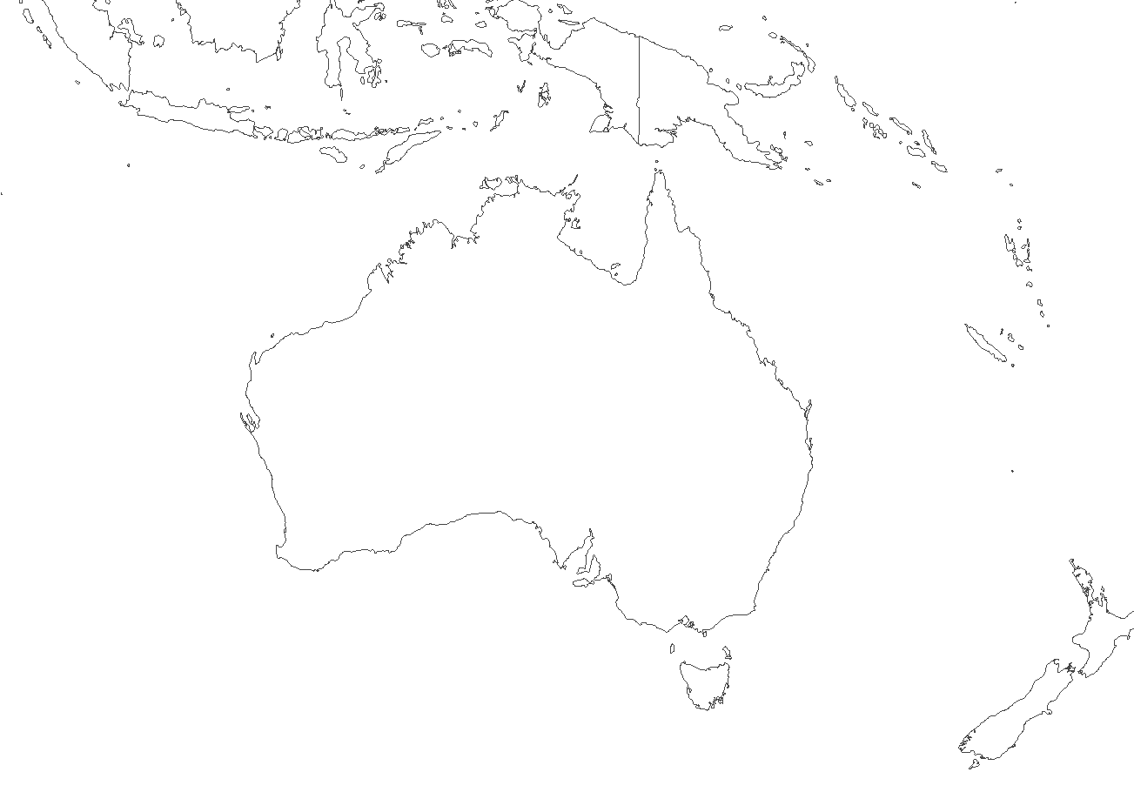

A u s t r a l i a

Figure 4.4. Finally, the map is centered on the region of interest with limited distortion.

Conclusion
Throughout this section we have discussed different issues raised by map projection properties. The user should be aware that at present most desktop-GIS offer the possibility to translate data sets into different projection frameworks, hence not limiting the selection process for a final suitable projection. Different selection schemes have been discussed, first from a parametric approach before reviewing the three main expert systems developed to assist users in their selection procedure. Selecting a suitable map projection reference is crucial, especially for small-scale mapping, where the choice of a wrong map projection can severely deform the message the map is meant to communicate. Both systems have advantages and serious drawbacks. The idea of a system that prompts the user to enter information about the geometric and general features, about properties of the projection (not discussed here), is very interesting if it includes also a coefficient optimization trough a series of interfaces. Once the projection has been determined, further GIS operations can be implemented easily.

Conclusion, outlook and future research
This study has provided an overview of map projections for world-scale mapping. A review of the distortion generated by map projections has given the reader some important background information in order to evaluate projections. A total of twenty-three projections corresponding to current available projections have been examined in terms of quantitative and qualitative distortion. However, not all of them are suited for the purpose of every map. Consequently, issues concerning the use and misuses of these projections have been evaluated as well. It appears that minimum-distortion projections reduce misuse of projections and should therefore be considered more often. Selection procedures that assist the mapmaker to choose a correct projection have been presented. If the user is not fully satisfied with a selected projection, the parameters of the projection can be further adjusted.

No single best projection exists, and it is a tedious process to select a framework that will best reflect the purpose of the map. Maps must sometimes be produced quickly, and too often the importance of the choice of an appropriate projection is underestimated. Some valuable results can already be attained if a favorable projection is selected. In the future, GIS providers should include a wider diversity of world and minimum-error projections. This would provide a broader variety of choices and improve the chance of an optimal selection.

Map projections at a larger scale have not been examined in this study. However, since distortion on large-scale maps is not really apparent, projection choice is not so much of an issue. Most GIS support many more projections for large-scale mapping than for small-scale mapping, which gives the user more freedom to select a favorable projection. Interrupted projections also have been disregarded in this study, because they are usually not supported by GISs. They have the advantage of reducing distortion over continental areas, but their interruptions make them unsuitable to map continuous phenomena.

Further research should be implemented on the integration of minimum-distortion projections within GIS and consequently on the feasibility of further parameter optimization. This would give the user maximal freedom and yield optimal results. In the future, the relation between the use of specific colors and the distortion generated by a projection should be examined as well. Highly distorted countries marked in a highly saturated color may reduce the meaning of the map.

Bibliography
American Cartographic Association (1989): The Case against Rectangular World Maps. Cartographic Journal, 26, 156-157.

Balthasart, M. (1935): L'emploi de la projection cylindrique équivalente dans l'enseignement de la géographie. Bulletin de la Société Belge d'Études Géographiques, 5 (2), pp. 269-272.

Brinker, D.M. (1990): Return of the orthographic projection as the best choice for world maps. ACSM-ASPRS Annual Convention, Technical Papers, 2, Cartography, Bethesda

Canters, F. (1989): New projections for world maps: A quantitative-perceptive approach. Cartographica, 26 (2), pp. 53-71.

Canters, F. (1995): A dynamic procedure for the selection of an appropriate GIS projection framework. In: Space Scientific Research in Belgium, 3: Earth Observation, Federal Office for Scientific, Technical and Cultural Affairs, pp. 77-90.

Canters, F. and Decleir, H. (1985): Projektiesystemen in de atlaskartografie van de 16de en 17de eeuw. Archief- en bibliotheekwezen in Belgie, 31, pp. 327-361 [in Dutch]

Canters, F. and Decleir, H (1989): The World in Perspective: a Directory of Map Projections. John Wiley & Sons, Chichester.

Canters, F. and Declercq, F. (1991): Wereld in Zicht, een nieuwe wereldkaart voor het middelbaar onderwijs. De Aardrijkskunde, 15 (4), 499-506 [in Dutch].

Dahlberg, R.E. (1991): Shaping the world map. In: A.H. Robinson and J.P. Snyder, eds. Matching the map projection to the need. Bethesda, Md., American Congress on Surveying and Mapping (ACSM), 18-9

Decleir, H. (1980): Het nieuwe wereldbeeld in Petersprojektie. Quardrijkskunde, 4 (2), pp. 125-132 [in Dutch].

De Genst, W. (1995): Ontwikkeling en implementatie van een systeem voor automatische afbeelfdingsselectie. De Aardrijkskunde, 1, pp. 1-16 [in Dutch].
Modified later in English as: De Genst, W. and Canters, F. (1996): Development and implementation of a procedure for automated map projection selection. Cartography and Geographic information Systems, 23 (3), pp. 145-171.

Gauthier, M.J. (1991): La carte dans les médias: la méconaissance des projections. Mappemonde, 2, pp. 45-47 [in French].

Gilmartin, P. (1985): The design of journalistic maps: purposes, parameters and prospects. Cartographica, 22 (4), pp. 1-18.

Goodchild, M.F. (1991): Progress on the GIS research agenda. In: Harts, J. H.F.L. Ottens and H.J. Scholten (eds.): Proceedings of the Second European Conference on Geographical Information Systems EGIS ’91, Brussels, Belgium, April 2-5, pp. 342-350.

Hsu, M.L. (1981): The role of projections in modern map design. In: L. Guelke, ed. Maps in modern cartography: Geographical Perspectives on the New Cartography. Monograph 27, Cartographica, 18 (2), pp 151-186.

Jankowski, P. and Nyerges, T.L. (1989): Design considerations for MaPKBS-map projection knowledge-based system. American Cartographer, 16 (2), pp. 85-95.

Iliffe, J. (2000): Datums and map projections for remote sensing, GIS and surveying, CRC Press, 150p.

Kaiser, W.L. (1987): A new view of the world: A handbook to the world map: Peters projection. New York, Friendship Press, 42 p.

Laskowski, P. (1991): On a mixed local-global error measure for a minimum distortion projection. In: Technical papers, 2, pp. 181-86. American Congress on Surveying and Mapping (ACSM) -American Society for Photogrammetry and Remote Sensing, Annual conference, Baltimore, Md.

Kessler, F. C. (1991): The development and implementation of MaPPS: An expert system designed to assist in the selection of a suitable map projection. State College, Pa., Geography Dept., Penn State Univiversity, Master's thesis, 241 p.

Kessler, F. C. (1992): Adapting to the changing needs of contemporary cartography through the development of new map projection selection strategies: a review. ASPRS/ACSM/RT92 Conference, Washington, D.C., Aug. 3-8, 1992, Technical Papers, v. 3, GIS and Cartography, pp. 284-293.

Loxton (1985): The Peters phenomenon. Cartographic Journal, 22 (2), pp.106-108.

Maling, D.H. (1991): Coordinate systems and map projections. In: Maguire, D.J. et al, editors, Geographical Information Systems: principles and applications, Longman Scientific and Technical, 1, pp. 135-146.

Maling, D.H. (1992): Coordinate systems and map projections. Oxford, Pergamon, 476p.

Martin, G.J., James P.E. (1993): All Possible Worlds: A History of Geographical Ideas. John Wiley and Sons, 585p.

McLeary, G.F. (1989): Review of Map: The World Issued by National Geographic Society. Meridian, 2, pp. 25-30

Mekenkamp, P.G.M. (1990): The need for projection parameters in a GIS environment. Proceedings of the First European Conference on Geographical Information Systems, Amsterdam, The Netherlands, April 10-13, pp. 762-769.

Monmonier, M. (1990): How to lie with maps. Chicago, University of Chicago Press.

Peters, A. B. (1984): Distance-related maps. The American Cartographer, 11 (2), pp. 119-131

Robinson, A.H. (1949): An analytical approach to map projection. Association of American Geographers, Annals, 39 (4), pp. 283-290.

Robinson, A.H. (1951): The use of deformational data in evaluating world map projections. Annals of the Association of American Geographers, Annals, 41(1), pp. 58-74.

Robinson, A.H. (1974): A New Map Projection: Its Development and Characteristics. International Yearbook of Cartography, 14, pp. 145-55.

Robinson, A.H. (1985): Arno Peters and his new cartography. The American Cartographer, 12 (2), pp. 103-111.

Robinson, A.H. (1988): Committee on Map Projections of the American Cartographic Association. Choosing a World Map: Attributes, Distortions, Classes, Aspects. Falls Church, Va.: American Congress on Surveying and Mapping, Special Publication 2 of ACA

Saarinen, T. (1999): The eurocentric nature of mental maps of the world. Research in geographic education, 1(2), pp. 136-178.

Snyder, J.P. (1985): Computer assisted map projections research. US Geological Survey Bulletin 1629. Washinghton D.C., U.S. Government Printing Office.

Snyder, J.P. (1987): Map projections: a working manual. U.S. Geological Survey Professional Paper 1395, 383 p.

Snyder, J.P., Steward, H. (1988): Bibliography of map projections. US Geological Survey Bulletin 1856. Washinghton D.C., U.S. Government Printing Office (updated in 1994).

Snyder, J.P., Voxland, P.M. (1989): An album of map projections. Washington: U.S. Geological Survey Professional Paper 1453

Snyder, J.P. (1993): Flattening the Earth, two thousand year of map projections. The University of Chicago Press, Chicago.

Snyder, J.P. (1994): How practical are minimum-error map projections? Cartographic perspectives, 17, pp. 3-9.

Tissot, A. (1881): Mémoire sur la représentation des surfaces et les projections des cartes géographiques. Gauthier Villars, Paris, 171p. [in French]

Tobler, W. (1962): A classification of map projections. Annals of the Association of American Geographers, 52, pp. 167-75

Wong, F.K.C. (1965): World map projections in the United States from 1940 to 1960. Syracuse, N.Y., Syracuse University, Master's thesis, 193 p.

 a French phrase which literally translates as Flat Square

